**Wireless sensing and data logging for cattle monitoring**

Final Report

**R.M. Lombard**

10119982

Submitted as partial fulfilment of the requirements of Project EPR402

in the Department of Electrical, Electronic and Computer Engineering

University of Pretoria

November 2015

Study leader: Prof. B.T.J. Maharaj

Copy 1 of 4

****Part 1. Preamble****

This report describes work that I have done in my final year project, developing a low power communication system for long distance data transmission.

This main report contains a copy of the approved Project Proposal (Section 1) and technical documentation (Part 4 of the report). The latter provides more detail on the hardware and software processes that was developed, and appears on the DVD that accompanies this report.

This document has been proofread by a knowledgeable person. By submitting this document in its present form, I declare that this is the written material that I wish to be examined on.

My language editor was_____________________________.

*___________________________ ________________________*

*Language editor signature Date*

*Declaration*

I, ________________________________ understand what plagiarism is and have carefully studied the plagiarism policy of the University. I hereby declare that all the work described in this report is my own, except where explicitly indicated otherwise. Although I may have discussed the design and investigation with my study leader, fellow students or consulted various books, articles or the internet, the design/investigative work is my own. I have mastered the design and I have made all the required calculations in my lab book (and/or they are reflected in this report) to authenticate this. I am not presenting a complete solution of someone else.

Wherever I have used information from other sources, I have given credit by proper and complete referencing of the source material so that it can be clearly discerned what is my own work and what was quoted from other sources. I acknowledge that failure to comply with the instructions regarding referencing will regarded as plagiarism. If there is any doubt about the authenticity of my work, I am willing to attend an oral ancillary examination/evaluation about the work.

I certify that the Project Proposal appearing as the Introduction section of the report is a verbatim copy of the approved Project Proposal.

_______________________ ___________________

R.M. Lombard Date

Table of Contents

Part 2. Summary Section v

Part 3. Main Report vii

1. Project Proposal 1

1.1. Problem statement 1

1.2. User requirement statement 2

1.3. Functional analysis 3

1.4. System specifications 6

1.5. Deliverables 8

1.6. References 9

2. Literature Study 10

3. Design and implementation 14

3.1. Approach 14

3.2. Detailed design and implementation 18

3.3. Design Summary 45

4. Results 47

4.1. Summary of results achieved 47

4.2. Qualification tests 47

4.3. Results and observations 47

5. Discussion 48

5.1. Interpretation of results 48

5.2. Aspects to be improved 48

5.3. Strong points 48

5.4. Under which circumstances will the current system fail? 48

5.5. Design ergonomics 48

5.6. Health and safety aspects of the design 48

5.7. Social and legal impact and benefits of the design 48

5.8. Environmental impact and benefits of the design 48

6. Conclusion 49

6.1. Summary of the work 49

6.2. Summary of the observations and findings 49

6.3. Suggestions for future work 49

7. References 50

Part 4. Technical documentation 52

List of Abbreviations

# Part 2. Summary Section

Cattle Monitoring

R.M. Lombard, Prof. B.T.J Maharaj

Abstract

I. Problem identification

II. Methods

III. Results

IV. Discussion

V. Conclusion

References

# Part 3. Main Report

## Project Proposal

### Problem statement

Motivation. Currently South Africans consume 700 000 tons of red meat per annum, and it is said to increase with 25% by 2020 [1]. The national beef herd, including the informal sector, is estimated at 13-14 million head. South Africa currently produces 85% of its meat requirement [2]. Due to low calving percentages and high mortality rates, the full demand can't be met. The problems are caused by poor cattle management, incorrect genetic mixture of cattle and using artificial insemination when the cow has low estrous levels. It is estimated that if calving percentages could increase by 35%, herd composition improved and carcass mass increased, the national beef supply could increase and sustain the nation without importing meat internationally [2]. This project will address the problem of cattle management by improving cattle monitoring and aiding in the detection of estrous behaviour to improve operation and efficiency, by genetics.

Context. Research has been conducted to determine if estrous behaviour can be determined by use of proximity sensors. The research showed an increase in interaction between cattle when estrous levels increased [3]. Some complications arise when cows go into calving [4], especially in heifers (a young cow before she has had her first calf). These complications can easily be countered by human intervention. This is not always possible as farmers are not always present. The project will extend on the research in behavioural patterns in determining estrous and social behaviour in cattle, by means of proximity sensing. It will also aid the farmers in determining a cow's health, especially during calving periods, to react before complications arise [5].

Technical challenge. The engineering challenge is to design and develop a device capable of (i) active real-time wildlife monitoring; (ii) recording proximity between animals; (iii) recording movement of an animal; (iv) wireless communication to a remote server; (v) being accessible from anywhere in the world; (vi) able to determine social and estrous behavioural patterns; (vii) to aid in managerial decisions, such as the use of artificial insemination, for each individual animal. The device will be piloted by cattle and can later be modified to support other farm animals and wildlife.

Limitations. The devices are required to be mobile, lightweight and comfortable for the animal to wear. The devices will have limitations in power consumption, as battery power will be used. Costs are also considered as a project constraint, as devices used and cost of the complete system should be kept as low as possible, with minimal loss in functionality. The device should operate independently for several days, therefore low power hardware will be required. It should be determined if solar power could be used to increase the lifetime of the devices, keeping the cost within budget. Ethical clearance will have to be gained for the electronic devices to be placed on the cattle. The challenge of working with live cattle will also have to be considered. Co-operation from the Faculty of Veterinary Science will be required to work with the cattle at Onderstepoort [6]. The use of live cattle will limit the number of testing opportunities.

### User requirement statement

#### Design Part of the Project

Task breakdown

Successful completion of the project will include the following tasks.

* A working prototype capable of detecting proximity between other devices, should be designed.
* A working prototype capable of detecting sudden changes in movement of an animal, should be designed.
* A mountable collar, capable of housing the hardware, should be designed.
* It should be investigated how motion and proximity sensing can be determined and data collected.
* Sufficient power supply should be investigated and a sufficient power source should be determined.
* A server should be set up, capable of processing the data and communicating with the devices remotely.
* A database needs to be designed, able to efficiently store and query the data received from the devices.
* Software should be designed capable of determining social patterns in the herd.
* Software capable in determining estrous behaviour within the herd should be designed and implemented.
* A mesh network should be implemented using XBee technology, capable of device and server communications.
* A user-friendly interface needs to be designed and implemented for easy access to the logged data.
* A notification system should be designed and developed, capable of notify the user remotely of estrous behaviour in individual animals.

Mission requirements of the product

Specific details of the system mission requirements are given below.

* The device should be mountable to each animal in a safe and non-discomforting way.
* The device should be robust and rigid enough to stay attached to the animal through rough motion, and be able to keep the internal hardware safe.
* The size of the device should not exceed 150mmx120mmx100mm, weighing less than 500 grams.
* The device should be powered by batteries, have a reasonable lifetime and recharge capabilities.
* A set of devices should be able to determine proximity between each other.
* A set of devices within close proximity should be able to recognise each other, and translate the data to the server.
* A device should be able to detect sudden changes in movement of each animal.
* Movement and proximity data should be logged on the device and communicated to the server.
* The server and database should be able to handle high volumes of data and must be scalable.
* Software running on the server should be able to detect estrous behaviour in each animal.
* The data should be easily communicated to, and be understandable by the average user.
* The server should give notifications and recommendations to the user in real-time.

#### Investigative Part of the Project

Research questions

The investigative part of the project is to determine if signal strength between wireless devices can be used to accurately determine the proximity of the devices to each other, and if not, find an alternative solution. Furthermore, battery technology and power requirements will be investigated, including the feasibility of solar power. It will also be investigated how proximity between animals, movement within social groups within the herd and sudden changes in movement determines estrous behaviour in animals. The question of interference between the device and the animal in close proximity will need to be investigated as it will affect the accuracy and reliability of the system.

### Functional analysis

The overall system will be broken down into three functional areas as given in Figure 1 to Figure 3.



Figure 1.

Functional diagram of devices worn by cattle.

The device referred to in Figure 1 is the physical device that will be mounted on the animals, and should be able log sensory data and communicate with a remote server. The processing unit (FU1.1) will receive data from units FU1.2 and FU1.4, which will then be processed to determine proximity between devices and sudden changes in movement. This data will be communicated to the server via FU1.3. For communication to the server (Figure 2), XBee devices connected in a ZigBee Mesh Network will be used. The proximity sensing unit (FU1.2) will determine if neighbouring devices are within close proximity, 1-2 meters of each other, inform the processing unit (FU1.1), and a contact event will be logged on the storage unit (FU1.5) and communicated to the server. The logged data will comprise of both unique identifiers of each device and the date and time of the event. The storage unit (FU1.5) will log data before it is sent to the server, and will serve as a local data backup. FU1.4 will comprise of an accelerometer to determine the movement data of the animals. This will provide data such as sudden changes in orientation or movement and determine whether the animal is standing or lying down. This data will be logged in terms of the directional axis of the sudden change in movement, together with the device's unique identifier. Finally, the power management unit (FU1.6) will strive to provide uninterrupted power to the device. The power management unit will comprise of a rechargeable battery and recharging circuitry coupled with a small solar panel that will be mounted on the animal. This will form part of the investigative study, see 1.2.2.



Figure 2.

Functional diagram of the remote server.

The remote server is referred to as a remote processing unit, capable of receiving data from the devices in Figure 1, and be able to process the data to give the user critical information about the animals. The remote server will be a web-server running the designed software to process and view the data. Raw data (FU2.1) will be received from the devices, after which it will be stored in a database (FU2.2). The database will be designed using SQL and will be scalable to handle large amounts of data. The software will determine social patterns within the herd. It will determine estrous behaviour (as researched and in collaboration with the Faculty of Veterinary Science of Onderstepoort) in individual animals, by processing (FU2.3) the raw proximity and movement data received from the devices in Figure 1. The processed data will be displayed on the User Interface (FU2.5). Along with the database running on the server, there will also be a background service (FU2.4). This service will poll the database at a predetermined time to determine anomalies in the data. Once an anomaly is found, such as high contact between cattle, contact between cattle in different social groups or sudden changes in movement, the service will send a notification (FU2.6) to the user, advising them to investigate. A user interface (FU2.5) will be designed using web interfacing software. This will be web pages, accessible across the world, where the user can query reports and data based on individual animals, social groupings and estrous behaviour. The reports will give the user crucial information in managing the cattle advising the user whether to use artificial insemination and information regarding the genetics of the given animal. The reports will be readable and understandable by users with little or no agricultural experience.



Figure 3.

Functional diagram of the network.

Finally a wireless network will be designed and built using devices such as XBee, utilising a ZigBee Mesh Network design. The network, shown in Figure 3, is defined as the communication between the devices, nodes and the server to send and receive data. Inter-device communication (FU3.6) will occur when the devices are within close proximity of each other, where after the device unique identification field will be transmitted and logged between devices FU3.1 and FU3.2. An N Number of devices can be connected. Server communication (FU3.7) will occur when the device communicates to send logged data to the server. This will be accomplished by communication between the device (FU3.1) and its closest node (FU3.3). After communication to the closest node, inter-node communication (FU3.8) will occur. This will allow the project to be scalable to greater areas, or areas with higher interferences that lead to lower signal strength and shorter communication distance. The final node (FU3.4) will communicate directly with the server. Data packets will be sent between devices and nodes, comprising of the data gather by the device.

The mountable collar will comprise of a housing unit, collar band, and recharging hardware. The housing unit will be a robust durable plastic housing, capable of housing the required hardware. It will be lightweight, yet tough enough to withstand rough use of the animals scratching and bumping it against the environment. The housing should in no way obstruct the animal’s movement. The collar band will be a durable material band that would not injure the animal, and be comfortable. Finally a small solar panel will be mounted on the collar band. The solar panel should not obscure the animal’s movement. All external wires will run through the collar band, to ensure they are not exposed and to keep the wiring safe along with keeping the animal safe.

### System specifications

#### Mission-Critical System Specifications

Detailed mission-critical specifications, as per Figure 1 to Figure 3, are given in Table 1 below.

|  |  |  |
| --- | --- | --- |
| SPECIFICATION (IN MEASURABLE TERMS) | ORIGIN OR MOTIVATION OF THIS  SPECIFICATION | SYSTEM COMPLIANCE TEST |
| The device (Figure 1) should log the ID of the neighbouring device, its own ID and the proximity measurement taken. | This specification is will be the driving force of the project. It is important not only to know the animal was in a contact event, but also the animal it was in contact with. | Two devices will be brought within proximity with each other, and the system will be checked. Two contact events should be logged, both containing the opposite device ID together with its own. |
| The software running on the server (Figure 2) should be able to determine social groups within the herd with 85% accuracy. | Social behaviour is key to determine estrous behaviour in herds. Estrous behaviour include moving from the animal's regular social group to another. | Social groups in a herd will be determined by guidance form the Veterinary Science department at Onderstepoort, and devices will be mounted on the animals. The results from the devices and server will be compared with the live result. |
| The software should be able to determine the animal’s movement within social groups. It should detect with 80% accuracy when an animal moves from one social group to another. | The movement within social groups are used to determine estrous behaviour within the herd. | Once social groups are determined, the animal’s social movement will be monitored, both physically and with the device, and results will be compared. |
| The Proximity Sensing Module (FU1.2) should log data when devices are within 2 meters of each other (line of sight), with 85% accuracy. | Proximity between cattle are critical in determining contact situations. The contact situations in turn determine behavioural patterns. | Two devices will be placed within 2 meters of each other, and the proximity will be calculated with the available data. This will be repeated 25 times, and the accuracy will be confirmed. |
| The Proximity Sensing Module (FU1.2) should determine the distance between devices accurately within 50 cm (line of sight). | The specification was chosen by taking in consideration the effects of interference in given environments. | Two devices will be placed within 2 meters of each other, and the proximity will be calculated with the available data. The software will respond with a digital calculation of the distance, and be compared. |
| Server Communication (FU3.7) should cover an area of minimum 80 hectares (line of sight). | Minimal nodes should be used to keep costs as low as possible, without compromising connectivity. | The nodes and devices will be set up in an available area, Onderstepoort, and connectivity tests will be conducted to determine the effective range of communication. |
| The device should not exceed 150mmx120mmx100mm | Cattle tend to rub themselves against trees. Limiting the size of the package will reduce to the possibility of damage to the device. | The package size will be measured and it will be determined if it complies with the limitations. |
| The device should be mountable on the animal, without causing discomfort. | The devices should record the animal's movements within the group. The device mounted on the animal should not cause distress. | The end product will be mounted on a live animal and it will be studied for a week. If the animal does not show signs of discomfort the specification shall be met. |

Table 1.

Mission-Critical System Specifications.

#### Functional Unit Specifications

Detailed functional unit specifications, as per Figure 1 to Figure 3, are given in Table 2 below.

|  |  |
| --- | --- |
| SPECIFICATION (IN MEASURABLE TERMS) | ORIGIN OR MOTIVATION OF THIS SPECIFICATION |
| The Processing Unit (FU1.1) should have enough communication and I/O ports to connect all the required peripherals. | Without the processing unit the sensory units would prove invaluable. Enough ports are required to connect the required peripherals. |
| XBee server communication (FU1.3) should be connected using a ZigBee Mesh Network design. | A mesh network will reduce communication traffic and also aid in reaching the range requirement. |
| The XBee modules (FU1.3) should have cyclic sleep functionality to reduce power usage, and use less than 70 mA average current | Since the device will be battery powered, using the minimal amount of power will be essential. |
| More than 75% of data packets should be received from the devices (FU1.3) given normal operating conditions. | A 75% efficiency will be enough to determine patterns in social and estrous behaviour accurately. |
| The Accelerometer (FU1.4) should be able to detect sudden changes in movement in 3 axes. | Sudden changes in movement could be used to identify social and estrous behaviour. |
| The Storage Unit (FU1.5) should be able to log up to 2 GB of data. | If communications are down or if cattle move out of range, data still has to be logged. |
| The Power Supply (FU1.6) should be able to be recharged using solar power. | Batteries can be removed and recharged, but in large scale operation it would prove too costly. |
| The Power Supply (FU1.6) should have a minimal operation time of 1 month, in normal conditions (Devices operating in clean line of sight conditions). | When artificially inseminated it will be able to change the batteries within the process. 1 Month lifetime would be acceptable. |
| The server (Figure 2) should be remotely accessible over a standard TCP/IP network. | The user should be able to check cattle remotely, since not all small-scale farmers are full-time farmers. |
| The Notification Service (FU2.4) should notify the user within 10 minutes of anomaly detection. | 10 Minutes after an anomaly is an acceptable response time, based on feedback. |
| The User Interface (FU2.5) should be web-based and easily accessible by means of a standard home computer and Internet connection. | Farmers are not necessarily computer literate or used to working on computer interfaces. The user interface should therefore be easy to use and understandable irrelevant the user's computer competency. |
| The network (Figure 3) should perform in real-time and data transfer should occur with minimal latency. | Data should almost instantaneously be available on the server, to give the user the sense of engagement. |
| The database (FU2.2) should be scalable, less than 5 % increase in processing time per 1 million data records. | Data should almost instantaneously be available on the server, to give the user the sense of engagement. |

Table 2.

Specifications of Functional Units.

### Deliverables

#### Technical Deliverables

|  |  |  |
| --- | --- | --- |
| DELIVERABLE | DESIGNED AND IMPLEMENTED BY STUDENT | OFF-THE-SHELF |
| Hardware required to determine proximity between devices. |  | X |
| Software required to determine proximity from hardware readings between neighbouring devices. | X |  |
| Hardware required to communicate to remote server |  | X |
| Hardware required to determine movement |  | X |
| Hardware required to process the sensor data |  | X |
| Hardware required to store data on devices |  | X |
| Hardware design, including the above specified modules that need to be selected and incorporated into the design. | X |  |
| A PCB design to incorporate hardware design above. | X |  |
| Software required to measure movement. | X |  |
| Software capable of determining social behaviour within the herd. | X |  |
| Software required to determine movement patterns. | X |  |
| Device-Server communication | X |  |
| Database design from first principles | X |  |
| Remote Server running required software. |  | X |
| Notification system and user interface. | X |  |
| Four mountable devices to use for testing and demonstration purposes. | X |  |
| Two Node devices to use for testing and demonstration purposes. | X |  |

Table 3.

Technical Deliverables.

#### Demonstration at the Examination

The following will be demonstrated at the examination:

1. Four device will be mounted on live animals that will log data prior to the demonstration.
2. The live data will be shown running on the server, by use of the User Interface.
3. Reports will be queried from the live server, and the results explained and shown.
4. A basic demonstration of how the device function will be shown.
5. Two devices will be at hand, connected with a node to a local server.
6. The devices will be placed out of proximity range of each other, and moved into and out of proximity.
7. The data logged from the devices will be shown on the local server.
8. Movement anomalies will be introduced by extensively moving the device.
9. The data logged from the devices will be shown on the server, along with the notification received by the user.
10. The communication range will be shown by referring to results taken prior to the demonstration.
11. The scalability of the database will be shown by data extrapolated from experiments done prior to demonstration.
12. The evidence of power requirements as reflected in the investigation on the relevant matter will be shown and discussed.

### References

[1] SouthAfrica.info. (5 March 2015) Southafrica.info. [last accessed 5 March 2015]. [Online].

Available:http://www.southafrica.info/business/economy/[sectors/542547.htm](http://www.southafrica.info/business/economy/sectors/542547.htm)

[2] J. de Jong. (5 March 2015) Farmers weekly. [Last accessed 5 March 2015]. [Online].

Available:http://www.farmersweekly.co.za/article.aspx?id=44228&h=[South-Africa’s](http://www.farmersweekly.co.za/article.aspx?id=44228&amp;h=South-Africa%27s-beef-industry%3A-what-does-the-future-hold)

[beef-industry:-what-does-the-future-hold](http://www.farmersweekly.co.za/article.aspx?id=44228&amp;h=South-Africa%27s-beef-industry%3A-what-does-the-future-hold).

[3] C. O’Neill, G. Bishop-Hurley, P. Williams, D. Reid, and D. Swain, “Using UHF proximity

loggers to quantify male-female interactions: A scoping study of estrous activity in cattle,”

Animal Reproduction Science, vol. 151, pp. 1–8, 2014.

[4] W. J. Grobler. (5 March 2015) Protea animal clinic. [Last accessed 5 March 2015]. [Online].

Available: http://www.proteaanimalclinic.co.za/Siektes/calving1.htm

[5] L. M. Schwalbach, I. B. Groenewald, and C. B. Marfo, “A survey of small-scale cattle

farming system in the North West Province of South Africa,” South African Journal of

Animal Science, vol. 31, no. 3, pp. 200–204, 2001.

[6] Onderstepoort location: M35 Onderstepoort Pretoria 0110, 25 February 2015, [Last

accessed 5 March 2015]. [Online]. Available: http://www.up.ac.za/[faculty-of-veterinary](http://www.up.ac.za/faculty-of-veterinary-science)

[-science](http://www.up.ac.za/faculty-of-veterinary-science).

## Literature Study

Analysis of cattle behaviour has become a crucial part of any successful livestock farmer. When looking at cattle and wildlife farming, it is especially important to be able to determine estrous behaviour in female animals as it is an economical component. When a female animal shows signs of estrous behaviour, reproductive methods such as artificial insemination (AI) are more likely to give successful results. The increase in successful reproduction increases calving percentages leading to greater economical yields [1].

Esselmont et al. [2] proposed an assortment of behavioural components in determining estrous behaviour, and how these components change when a cow reaches estrous. The study quantified these components and found that all components were shown even when the cow was not asserting estrous behaviour, albeit low or very low frequencies. Once the cow was nearing estrous, these component frequencies increased.

Similarly, in studies conducted by Solano et al. [3] and Sveberg et al. [4] it was shown that components of behaviour in cattle such as: licking, butting, attempts to mount, mounting and movement in social groups, were indicators of estrous behaviour. Both studies were conducted using visual observers over periods, to count and record the physical estrous indicators, or interactions, and comparing the results with veterinary evaluations of cattle. The results showed an increase in interactions between the cattle when the cows were in estrous.

From these studies, it can be concluded that these behavioural components or estrous indicators can be quantified as an action where two animals are within proximity between each other for a period, further referred to as an interaction. When the number of interactions and length of interactions increase, it can be concluded that the female animal shows estrous behaviour.

Proximity loggers have long been in use to determine and quantify intra- and interspecies interactions. Proximity loggers collect interaction histories, over a specified period, and allow researchers to retrieve the data for analysis. The analysis of the data in turn produces social and behavioural patterns within the sampled animal community, which can be used to determine estrous behaviour.

In 2012, Drewe et al. [5] conducted a study to determine the performance of proximity loggers used in a field based test compared to that of a laboratory test. For the field test proximity loggers were mounted on cattle by means of a collar, with data recording over a period of 15 months (although not all collars collected data over the whole time period due to the loggers reaching maximum capacity of 16 384 records). The laboratory test validated the reach and accuracy of the loggers, both before and after the 15-month period. It was shown that due to decreases in battery life, a moderate reduction in initiation and termination distances and a widening in range detection occurred. To validate the field test, visual observations of interactions were taken by an observer over a two-day period. The cattle were observed for 30 minutes from a distance of approximately 20 meters. Cattle were considered to be interacting when they were within one head's width of another animal. The results showed the loggers logged 129 out of the 179 (72%, range 50% to 94%) interactions observed by the observer during the six hours of visual observations.

In a study conducted by Walrath et al. [6] in 2011, White-Tailed Deer were captured and held in an observation field. A proximity logger was mounted on the deer with a collar. Two pairs of deer were placed in the observation field, and an observer would count interactions between the deer. A total of 72 hours of observer data and 432 hours of proximity logger data were taken. To ensure objectivity and the deer to continue previous behaviours, the observer entered the field 15 minutes before the recording was initiated. Interactions were defined as occurring when the deer were within 1 meter of each other (approximately the body length of the deer). As a result the observer recorder 500 interactions, whereas the loggers recorded 774 interactions. The efficiency of the loggers was found to be 64% versus the 34% of the visual observer.

From the studies above, it can be concluded that proximity loggers are able to accurately record interactions between animals, and in some cases better than visual observers are. The loggers are also capable of recording data for extended periods, which is not possible with visual observers. It can also be concluded that although proximity loggers are efficient, battery life and environmental factors has an influence on the accuracy of the data recorded.

As a confirmation of the studies conducted by Esselmont et al. [2], Solano et al. [3] and Sveberg et al. [4]; O'Neill et al. [7] conducted a study in 2014 to determine if using proximity loggers to quantify male-female interactions would provide information regarding estrous behaviour in cattle. The study found 2-3 times more interactions for estrous cows than non-estrous cows, with the interactions lasting 3-5 times longer. The study concluded that proximity loggers are capable of recording inter-animal interactions with both wildlife and livestock.

From the relevant studies, it is clear that proximity loggers are a helpful tool that can be used in both livestock and wildlife management, although it is presented with a few shortcomings. In all cases, the loggers were mounted on the animals, left for a period, and then removed. Only after the devices were removed could the data be analysed. In some cases, the loggers ran out of memory, and were not able to record data until it was removed and wiped. Decreasing battery lifetime reduced the efficiency of the loggers.

As a supplement to the list of behavioural components, a study to determine estrous behaviour in cattle based on walking activity was conducted by Silper et al. [8] in 2014. The study monitored cattle by using accelerometers and video observations to better understand the behavioural expression of estrous. The number of steps taken by the cattle was monitored. It was reported around 100 steps per 8 hours as a baseline and 400 steps per 8 hours of estrous. Thus, it could be concluded that an increase in walking (steps taken) can be seen as an indication of estrous behaviour in cattle.

Chanvallon et al. did a comparison study [9] between using a pedometer (accelerometer aided by software to determine steps taken) and two activity meters (a Heatime-RuminAct and a HeatPhone), to evaluate their relative performance. The data was collect on the devices over a given period, and transmitted to a central database using radio telemetry. The reliability of each device was defined by their sensitivity to correctly detect estrous behaviour and the accuracy in positive detection. The results showed higher sensitivity in the pedometer (71% versus 62%) to detect estrous behaviour, but a lower accuracy of positive detection (71% versus 84%). Although the pedometer gave less accurate results, the results were still able to show conclusively that estrous behaviour can be detected by using a pedometer.

Reproductive efficiency is an important determinant of profitable cattle breeding operations, as well as the success of assisted reproductive techniques in wildlife conservation programs. The use of artificial insemination (AI) can greatly yield higher pregnancy rates in a livestock farmer’s cattle. From a managerial perspective, it also allows the farmer to more accurately determine the year’s expected cost and profit, since it is possible to know when a cow is going to be pregnant. AI also increases the likelihood for a cow to become pregnant versus natural insemination (NI), as the farmer can say with certainty that a cow has received semen.

When artificially inseminating cows, one of two techniques can be used, Fixed-Time Artificial Insemination (FTAI) or AI after estrous detection (EDAI). FTAI is used after successful implementation of an ovulation synchronization protocol. All cows are then artificial inseminated on the same predetermined time. Alternatively, EDAI relies on estrous detection, and once a cow is found to show estrous behaviour, she is artificially inseminated. Both of these techniques have their respective advantages and disadvantages. In a comparative study by Edwards et al. [10], it was shown that using EDAI, the cost per calf was reduced by $23.70 (AUD) versus FTAI. Taking in to consideration the high yields required of commercial beef farms, such a reduction in cost can produce high profit gain.

When a cow shows estrous behaviour, it does not necessarily mean she has to be artificially inseminated or be placed with a bull to be naturally inseminated. It is possible for a cow who has just reached puberty to show estrous behaviour, but it is advised to wait until she reaches an age of 13 to 15 months. It is also important for heifers to reached 60% to 65% of the average mature weight of the herd before she can breed [11].

It is also important to consider the cows birthing history when deciding whether or not to AI the cow, since semen can be expensive, and should not be wasted on a cow yielding low birthing success. After a cow has giving birth, estrous behaviour might be show, but it is recommended to rest the animal’s body for at least 55 days before inseminating her again [12].

One of the greater benefits of AI is that it is possible to know exactly where the semen came from, and it is easier to accurately create a genetic history or bloodline for the calf. Semen can be purchased from bulls that have specific genetic traits that may be beneficial by increased growth rates, specific profile builds of the animal and prolonged longevity. These benefits lead to increased profitability and ultimately a more successful business [13].

Finally, it can be concluded that not only is it important to know when an animal shows estrous behaviour to artificially inseminate the animal, but also what managerial decision to take to produce the best result. By determining estrous behaviour successfully in female animals may lead to an increase in pregnancy rates and successful insemination (natural or artificial). Basing managerial decisions on inseminated the animal, such as age, previous birthing success and genetic mixture will lead to an increase in production and a reduction in cost of calf and ultimately an increase in production profitability.

This project will aim to extend on the research done, by improving on the current issues of the proximity loggers and building a platform capable of real-time data recording and analysis.

The project will work towards building a wireless network for the devices to connect to. The network will allow the devices to directly communicate with a remote server capable of analysing the data recorded, and give real-time results. This will allow the researcher and user to be notified when estrous behaviour is detected and respond accordingly within 4 to 12 hours of detection [14].

The project will be used as a tool to further study social patterns in determining estrous behaviour in both cattle and wildlife, by means of proximity sensing and movement analysis. It will benefit the research to conduct real-time studies over a wide range of environmental factors. The project will benefit the user by increasing the reproduction by means of artificial insemination. In turn, this will increase productivity and economical yields.

Furthermore, the project will aim to aid in making managerial decisions for the cattle, by referring to the literature and research available and extending there on. The project will create a platform where data can be collected from various study groups, over an endless range of research area, which can be monitored and processed in real-time. The information gained from the research can in turn be directly incorporated back into the project, and give users real-time updates to improve estrous detection based on the latest studies.

## Design and implementation

### Approach

Most of the proximity loggers used by the respective studies as mentioned in section 2 make use of UHF RFID to record interactions between devices. It was considered to make use of the same technology, but the idea was abandoned due to the complexity associated with communicating with both UHF RFID operating between 300MHz and 3GHz, coupled with a long-range communication protocol operating at 2.5GHz. Instead, it was considered to use only one form of wireless signal communication, for both short and long-range communication.

It was decided to use XBee Series 2 modules for communication. The XBee modules communicate over a 2.5GHz ZigBee Mesh protocol. This protocol allows the modules to dynamically set up a mesh network, making it ideal for the required set up where animals move between grazing fields. When set up as Router devices (see Figure 4), the XBee modules are capable of determining signal strength between each other. It was decided to use this signal strength to determine distance between two devices, as the exact distance is not required. It is only important to know when two device are within an approximate proximity from each other, which can be translated to signal strength.

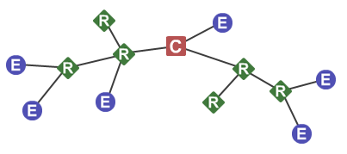

Figure 4.

ZigBee Mesh Network. With E: End Device, R: Router Device, C: Coordinator Device.

One drawback of using the XBee modules as Router Devices is the high current draw. It will increase the load on the batteries, and it was decided to use a different approach. Low powered Wi-Fi modules were sourced and it was seen that these devices could also determine signal strength between different available Wi-Fi networks. The advantage of using these devices is the low power consumption. When incorporating the Wi-Fi modules into the design, the XBee modules could be used as End Devices, which meant much lower power consumption, and an overall decrease in the load of the ZigBee Mesh Network.

It was decided that proximity between devices will be calculated using signal strength between the Wi-Fi modules, and communication to a remote server will use the XBee modules using a ZigBee Mesh Network.

To determine sudden changes in movement by the animals, a 3-axis accelerometer was considered. The accelerometers measure acceleration in the respective three axis, and outputs an analogue value based on the acceleration in the measure axis. To determine sudden changes in acceleration, or movement as referred to in this document, it was decided to use a microprocessor to read the analogue values at given times, using the built-in ADC coupled with a low pass filter. The values were stored and a second set of values were measured. The two sets of values were then compared and when a sudden change occurred, the data was passed over the network to the remote server.

It was decided to implement the design in software rather than hardware, since a microprocessor was already required to allow communication within the network. The software implementation would also mean less complexity within the final circuit design and the use of less components. Furthermore, data that are more accurate could be obtained.

It was considered to use the accelerometer to recreate a pedometer, and count the steps taken by each animal. The idea was left for a future project due to time constraints. The implementation of a pedometer to calculated step taken may have resulted in more accurate determination of estrous behaviour, but the data acquired from proximity sensing was good enough to give indication of estrous behaviour, and was favoured for the project.

For data communication, the ZigBee Mesh Network was considered. The network allows the devices to communicate with each other using the same PAN ID. Each network requires at least one Coordinator Device and one Router Device and was set up similarly to Figure 4.

The network was set up with XBee Series 2 modules. The devices that will be physically mounted on the animals, each received an XBee module, set up as an End Device. The devices used a shorter ranged XBee module, namely a 2mW module, capable of a communication range of 100m.

End Devices could be placed in a cyclic sleep mode, which consumes less power when the device is not communicating. The End Devices were programmed to only send out data and not receive, as communicating to the devices was not required and less power would be used. The End Devices were connected to Router Devices, referred to as nodes. Nodes were placed in fields across a farm or monitoring area. It was required that a node be placed every 100m in an area that spanned more than 600m².

Each node was a high range XBee module, namely a 63mW, capable of a communication range of 1.6km. Each node connects to a single and final Coordinator Device, referred to as a web-node. The web-node connects to the Internet, and sends all the data received from the devices to the remote web-server. It was decided that basic processing of data received would be process at the web-node using a Python script. This decision meant that the devices would require a lot of processing power, and that an ultra-low powered microprocessor could be used.

Data was simply sent over the ZigBee protocol, in which the modules automatically package the data and sends it to the pre-programmed web-node address. Since data packets cannot exceed a size constraint, the data was split into multiple packets. Once data was received by the web-node, a Python script decoded the packets and rebuilds the data received. The data was the processed and sent to the remote server for analysis.

To determine the proximity between devices, sudden changes in movement, and communication, the devices required a significant power source. Many of the design choices were based on low power consumption, to allow greater operation lifetime, since battery power was to be used. It was decided to use a lithium polymer battery (LiPo) as it could be recharged multiple times, and offered great power storage capabilities. To further extend the lifetime of the LiPo batteries, it was considered to incorporate a charging circuit into the device. The charging circuit used a solar panel as input to charge the battery.

To increase battery life and decrease circuit complexity, it was decided for all modules used in the device design show operate at 3.3V and be low or ultra-low powered modules. By using modules that were all powered by 3.3V meant no voltage step-down would be required. This also meant much less power would be dissipated into heat, ultimately reducing the heat dissipated by the device making it saver for the animal to wear. Using low or ultra-low powered modules meant reducing the load on the battery, thus increasing its lifetime.

The devices are required to be mountable on the animals. This meant devices should be kept small and light enough to not cause discomfort for the animal, yet bet rigid and strong enough to withstand the elements. A design of the enclosure was done using SolidWorks, and kept within the specified size constraints. The enclosure was made mountable by means of a durable collar, which was placed around the animal’s neck or chest, similar to Figure 5.Figure 5. It was held in place by buckles that could easily tighten to the required tightness and not harm the animal.

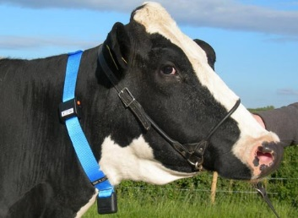

Figure 5.

Example of collar with buckles.

It was considered to store data collected by the devices on two separate data storage units. An on-board unit, namely a MicroSD Card for each device, and a Microsoft SQL Server (MSSQL) database, which would run on the remote server and store data for all devices. The use of on-board storage for each device meant that data could be captured per device even when the device was not able to communicate to the remote server. A standard FAT16 or FAT32 file system was considered to be used to store raw data in text files on the MicroSD Cards.  
  
A MSSQL database was considered for its robustness and ease of indexing and analysis to speed up the database. A MSSQL database is also capable of storing large volumes of data, and expanding its size dynamically. All the data received by the remote sever was inputted into the database using Stored Procedures. This meant the SQL statements would be separate from the software running on the server, which meant changes could be made to the SQL statements without effecting the software.

The database allowed the multiple users or farms (study groups), to store data on a single access point for processing. It also made it possible to speed up processing time when determining estrous behaviour, due to the nature and structure of SQL.

It was decided to develop a user interface to run as a standard website on the remote server. A website can be accessed remotely, and run on any device with a web browser. The user interface was developed using Visual Studio 2013 and coded using ASP.NET utilising the MVC framework. MVC was chosen for it is easy to use structure and code encapsulation.

Security was required for the user interface to allow multiple users access to specific data. This was accomplished by using ASP.NET’s build in Form Authentication security measures, and it was incorporated into the database. This made it possible to give users access to data that is only available for the specific user. This added scalability to the project, and made it possible to create an audit trail. The audit trail keeps track of every change or action made by the user.

The user interface was designed with management functionality in mind. This allowed users to keep historical data of each animal in their respective herd, and gave a visual representation of all the data gather. This could help users in making important managerial decisions for individual animals.

Finally, data processing was accomplished by means of a console application written in C#. C# was chosen because the software could easily be compiled into an executable file. The executable was then used and run by the server as a task at specified intervals.

Data processing comprised of determining social groups of each animal, number of interactions and average length of interactions over a given period. This data was then compared against the historical data of each animal. When significant changes occurred, the animal was flagged as showing estrous behaviour.

For every animal flagged, all the users associated with the animal were notified using one or all three available methods. It was considered to develop an Android application that users can install to receive notifications from the system. This was abandoned due to time constraints and availability of Android devices by users. It was decided to give users a choice between three notification methods, e-mail, SMS or using the Push Bullet application (available on both Android and Apple). The user can enter their desired notification method and enter his/her details, and receive notifications on that channel. An overview of the entire project is shown in Figure 6.

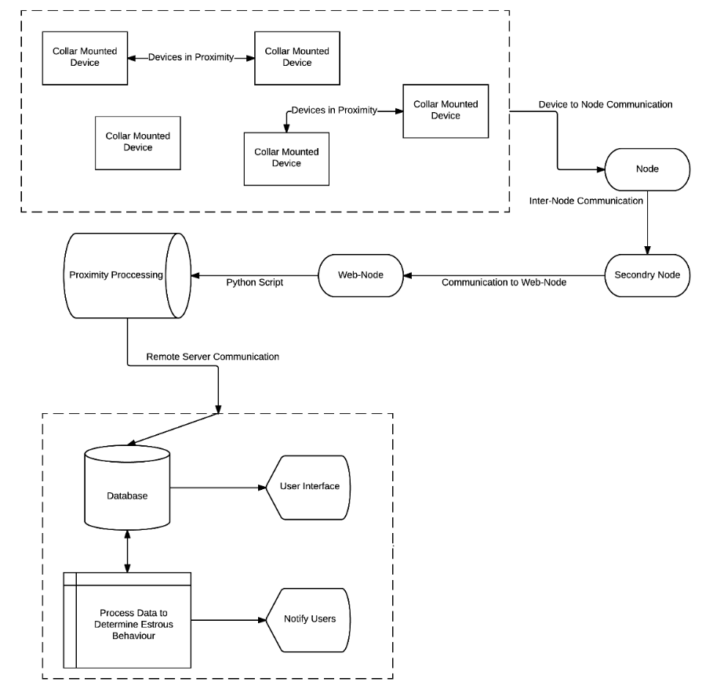

Figure 6.

Overview of entire project.

### Detailed design and implementation

#### Hardware Design and Implementation

##### Proximity Sensing Hardware

The main hardware component of the project is the proximity-sensing module. Proximity sensing is done by using an ESP8266 Wi-Fi Serial Transceiver Module as depicted in Figure 7. The module has been specifically designed for mobile applications with the aim to achieve ultra-low power consumption. The module only uses 12µA as stated in the datasheet, making it the ideal choice to use as a proximity-sensing module and it operates at 3.3V

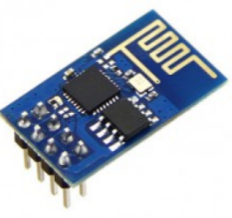

Figure 7.

ESP8266 Wi-Fi Serial Transceiver Module.

Proximity sensing is done by setting each individual ESP8266 module to AP + Station Mode and setting the modules’ unique identifier. The unique identifier for each module is set to lower 8-bits of the XBee modules MAC Address (discussed in 3.2.1. (c)). This is accomplished by issuing two AT commands via a serial connection between the microprocessor and the ESP8266 module. Both commands are issued before the ESP8266 module is connected to the device circuitry.

First the AT command AT+CWMODE=3 is issued. This command sets the module to act as both a Wi-Fi Access Point and Wi-Fi station, allowing the module to be listed by other modules when scanning for available Wi-Fi SSIDs.

The second AT command issued is the command AT+CWSAP=ssid,pwd,ch,ecn. This command sets the Wi-Fi Access Point and SSID for the module. The ssid parameter (SSID) is set to the lower 8-bits of the XBee modules MAC Address to uniquely identify each module. The pwd parameter (password) is set to an empty string. The ch parameter (channel) is set to 1 and the ecn parameter (encoding) is set to 0, thus creating an open Wi-Fi network. Examples of the AT commands and responses are shown in Figure 8.Figure 8.

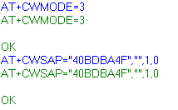

Figure 8.

Configuration AT Command issued to the ESP8266 Wi-Fi Serial Transceiver Module and the response received, using Termite 3.1 Serial Communication software. Commands shown in blue are sent to the module, and commands in green are the responses given by the module.

After the modules have been set up, the device can start sensing proximity. This is accomplished by issuing an AT command to the module at intervals of one seconds each. The AT command AT+CWLAP returns a list of all the available SSIDs as shown in Figure 9. The list is sorted by channel, thus the reason for setting the channel of each module equal to 1 in the configuration phase.

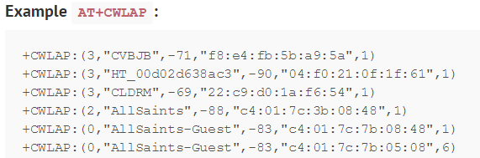

Figure 9.

Example of list returned by issuing the AT+CWLAP command on the ESP8266 Wi-Fi Serial Transceiver Module.

The microprocessor issues the command every second, and the response from the module is read into a buffer on the microprocessor, as discussed in 3.2.1. (f). The buffer has a fixed size, 350 characters. Once the buffer is full, it is sent to the XBee module, which in turns communicates the data to the web-node for processing, as discussed in 3.2.3.

##### Movement Detection Hardware

As a requirement, the device should be able to detect sudden changes in movement. A sudden change in movement is defined as a sudden increase in acceleration on an axis of movement. To accomplish this, a 3-axis accelerometer is used, namely an ADXL335 module.

As stated in the ADXL335’s datasheet, the module is a low power device, making it an ideal choice for the project. The module requires 1.8V to 3.6V of input power, and the module is packaged in a low-profile design at only 4mm x 4mm x 1.45mm. The module measures acceleration with a minimum full-scale range of ±3 g, enough to detect sudden change in movement. The module, with typical connection circuitry is shown in Figure 10.

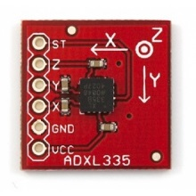

Figure 10.

ADXL335 with typical circuitry on a breakout board by Sparkfun Electronics.

For the ADXL335 module to perform properly some bandwidth, calculations are required. The module has provisions for band limiting the ${ X}_{out}$, $Y_{out}$ and $Z_{out}$ pins. Capacitors must be added at these pins to implement low-pass filtering for antialiasing and noise reduction.

The equation for the 3 dB bandwidth is:

$F_{-3dB}=\frac{5µF}{C_{\left(X,Y,Z\right)}}$ (1)

The tolerance of the internal resistor typically varies as much as ±15% of its nominal value (32kΩ) and the bandwidth varies accordingly. A minimum capacitance of 0.0047μF for $C_{X}$, $C_{Y}$ and $C_{Z}$ is recommended in all cases. Typical values are shown in Table 4.

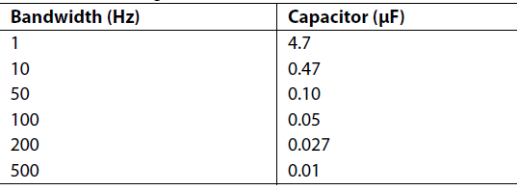

Table 4.

Typical bandwidth selection for ADXL335 and the corresponding Capacitor required.

The selected accelerometer bandwidth ultimately determines the measurement resolution. Filtering can be used to lower the noise floor to improve the resolution of the accelerometer. A bandwidth of 50Hz was selected with ${ C}_{X}=C_{Y}=C_{Z}=0.1µF$, to minimise aliasing.

To determine sudden changes in movement, the analogue outputs of the accelerometer ${ X}_{out }$, $Y_{out}$ and $Z_{out}$ are sampled by the microprocessor’s ADC. Five consecutive samples are taken for each output and stored in an array. After 500ms, the sampling process is repeated except the results are stored in a separate array. Using low-pass filtering and shock detection, as explained in 3.2.1. (f), changes in movement in either axis is determined.

Once a change in movement is detected, a flag is pushed to the data buffer to be sent to the web-node for processing. The flag is simply a bit stored in the data buffer. There are three change in movement bits, each representing a curtain axis of movement. Further details about processing the change in movement is discussed in 3.2.3.

##### Communication Hardware

For long-range communication, the devices use XBee Series 2 2mW modules, as shown in Figure 11. The modules are capable of transmitting data over a wireless serial link and operate at 3.3V. The modules are connected to the microprocessor via a serial connection.

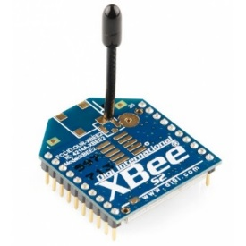

Figure 11.

XBee Series 2 2mW Module as manufactured by Digi.

The XBee modules communicate via the ZigBee Mesh Network, and are set up as End-Devices (see Figure 4). The modules are configured by using XCTU by Digi. The software creates a serial communication link between a computer and the connected module, and creates an interface for the user to set various configuration parameters on the XBee module.

All End Device are configured using the parameters shown in Table 5. The modules are configured to use AT mode. In AT mode modules cannot be remotely configured, and data is sent directly over serial without any packaging. This is favoured above setting the modules in API mode, where data has to be packaged in packets before it can be communicated over the serial link from the microprocessor to the XBee module.

|  |  |  |
| --- | --- | --- |
| Setting Parameter | Configuration Value | Description |
| Firmware Version | 28A7 | Latest Firmware |
| Function Set | ZigBee End Device AT | Set module to use ZigBee networking protocol and set module as End Device operating in AT mode. |
| PANID | 8 | Personal Area Network ID. Must be the same for all XBee modules. |
| JN (Join Notification) | 0 – Disabled | Disable join notifications to decrease load on networks with many devices. |
| DH  (Destination Address High) | 13A200 | 8-Bit High Address of Coordinator module in network, where all data is sent. |
| DL (Destination Address Low) | 40BEFB56 | 8-Bit Low Address of Coordinator module in network, where all data is sent. |
| BD (Baud Rate) | 19200 | Set Baud Rate for serial communication to 19200. |

Table 5.

Configuration for XBee Series 2 2mW modules as Collar Devices.

Once the data buffer on the microprocessor is filled by data returned from polling for proximity, as discussed in 3.2.1. (f), the microprocessor transmits the data buffer to the XBee module character per character. Once the XBee module has receive the buffer it gets the data ready to transmit it to the nearest node and ultimately to the web-node.

A node consists of an XBee Pro Series 2 63mW module (Figure 12Figure 12.), connected to a battery and solar panel, utilising the same charging technology as discussed in **Error! Reference source not found.**. The module can transmit data over a 1.6km range as stated in the datasheet, and requires a transmit current of 205mA to do so. The nodes communicate via the ZigBee Mesh Network as Router devices. Nodes are configured using the parameters in Table 6.

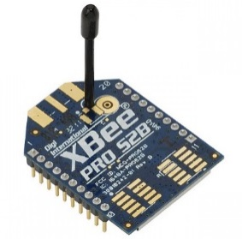

Figure 12.

XBee Pro Series 2 63mW Module as manufactured by Digi.

|  |  |  |
| --- | --- | --- |
| Setting Parameter | Configuration Value | Description |
| Firmware Version | 23A7 | Latest Firmware |
| Function Set | ZigBee Router API | Set module to use ZigBee networking protocol and set module as Router operating in API mode. |
| PANID | 8 | Personal Area Network ID. Must be the same for all XBee modules. |
| JN (Join Notification) | 0 – Disabled | Disable join notifications to decrease load on networks with many devices. |
| DH  (Destination Address High) | 13A200 | 8-Bit High Address of Coordinator module in network, where all data is sent. |
| DL (Destination Address Low) | 40BEFB56 | 8-Bit Low Address of Coordinator module in network, where all data is sent. |
| BD (Baud Rate) | 19200 | Set Baud Rate for serial communication to 19200. |

Table 6.

Configuration for XBee Pro Series 2 63mW modules as Nodes.

Nodes are configure in API mode, or transparent mode. In this mode modules can be configure remotely and data has to be packaged in packets before it is transmitted. Using packets makes it possible for data to be received from multiple devices without cross talk. Each packet contains the source address in its header bits, thus data from multiple devices can be broken into separate packets, transmitted across the network, and rebuilt for processing.

Once data from the microprocessor is received by the XBee module, it automatically constructs packets as required by the ZigBee Mesh Network protocol. Once the data is packaged, it is sent one by one to the nearest node. A node receives the packets, and redirects it and transmits to the assigned web-node.

There is only one web-node in each communication network. The web-node consists of an XBee Pro Series 2 63mW module (Figure 12) and communicates via the ZigBee Mesh Network as a Coordinator, as shown in Figure 4. The web-node is connected to a computer using an XBee Explorer Serial-to-USB. The computer has a working Internet connection. The web-node is configured using the parameters shown in Table 7.

Once packets are redirected from the nodes to the web-node, the web-node receives each packet as they arrive. Packets are decoded and rebuilt using software running on the connected computer and are discussed in 3.2.3. An example of a functioning network can be seen in Figure 13.

|  |  |  |
| --- | --- | --- |
| Setting Parameter | Configuration Value | Description |
| Firmware Version | 21A7 | Latest Firmware |
| Function Set | ZigBee Coordinator API | Set module to use ZigBee networking protocol and set module as Coordinator operating in API mode. |
| PANID | 8 | Personal Area Network ID. Must be the same for all XBee modules. |
| BD (Baud Rate) | 19200 | Set Baud Rate for serial communication to 19200. |

Table 7.

Configuration for XBee Pro Series 2 63mW modules as Web-Nodes.

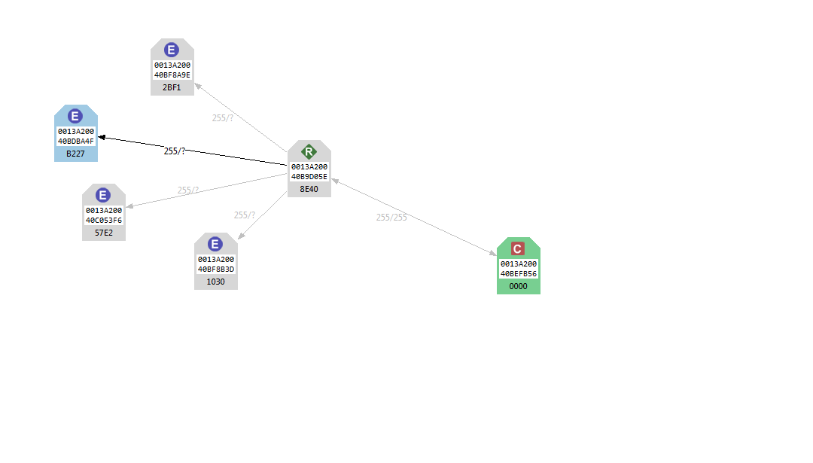

Figure 13.

ZigBee Mesh Network configured for the project. Where modules E are Collar Devices, modules R are Nodes and modules C the Web-Node.

##### Device Power

Collar devices are powered using an 8800mAh 3.6V LiPo battery, shown in Figure 14.Figure 14. The battery was chosen because of its storage capabilities of 8800mAh and its size of 65mm x 35mm x 35mm.

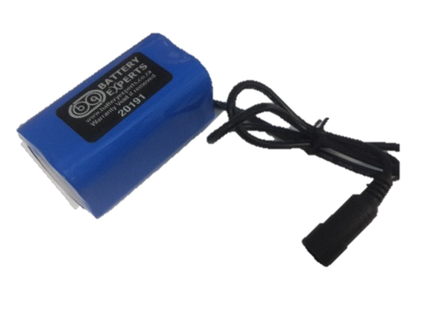

Figure 14.

8800mAh 3.7V LiPo Battery as manufactured by Battery Experts.

The battery is charged using a MCP73833 charge controller (example in Figure 15). The charge controller is capable of charging a battery with charge current of 1A. LiPo batteries cannot be overcharged, and the controller regulates the charge to the battery. Once the battery is fully charged, the controller switches of charging to the battery and directly supplies power to the load (the collar device circuitry as shown in Figure 16Figure 16.).

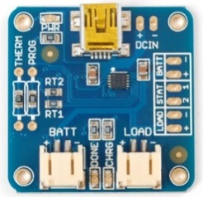

Figure 15.

MCP373833 configured in a breakout board by AdaFruit. The Mini-USB port provides input power, and BATT and LOAD provides output power.

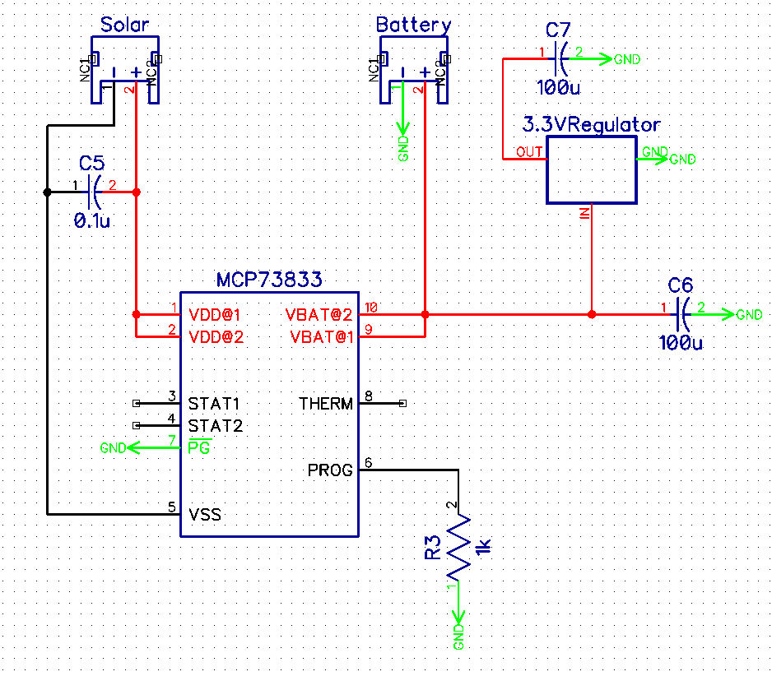

Figure 16.

Circuitry required for MCP73833 module, to supply power to the collar device.

It was investigated if a solar panel would be capable of increasing the expected power lifetime of the collar devices. It is shown that a small 0.9W solar panel can provide enough input current to charge the LiPo battery. Each collar device has provisions to connect a 0.9W 5V solar panel (Figure 17), which can be mounted on top of the enclosure of the collar device, or on the collar, depending on the animal it is connected to. The solar panel is sized at 110mm x 80mm and can supply a current of 180mA.

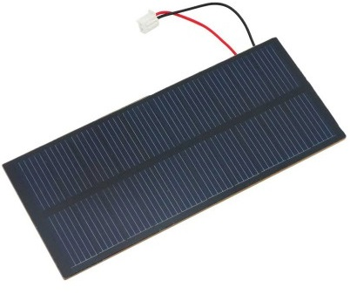

Figure 17.

0.9W 5V Solar panel used to supply power to the battery-charging controller.

The approximate expected battery usage is shown in Table 8. The calculations are based of the respective datasheets for each component. The XBee modules average power requirement is based off the official battery-lifetime calculator provided by Digi and shown in Figure 18.

|  |  |
| --- | --- |
| Component | Average expected current drawn (µA) |
| Microprocessor | 8 |
| Wi-Fi Module | 10 |
| XBee Module | 4500 (see Figure 18.) |
| Accelerometer | 350 |
|  | 4868 |

Table 8.

Battery usage per component.



Figure 18.

Average power usage of the XBee Series 2 2mW module as used in the collar device. Calculations are based on the average operation times. The total system currents are based of the values given by the datasheet.

Based on the calculations above the total expected battery lifetime is calculated using equation (2) and should provide power to the collar devices, without using the solar panel to charge the battery, for approximately 75 days. This translates to about 2.4 months of expected battery life, which is two times greater than the specification of one-month battery life requirement. Since the battery life requirement has been met, the solar panel is not required to be connected to the collar device, but provisions there-for have been made.

$Total expected battery lifetime= \frac{Battery size \left(mAh\right)}{Total expected usage \left(mA\right)}× \frac{1}{24}$ (2)

$$Total expeceted battery lifetime= \frac{8800}{4.868} × \frac{1}{24}≈75.322 days$$

##### Storage Hardware

Each collar device is fitted with a MicroSD slot, where a MicroSD Card can be inserted to (as shown in Figure 19Figure 19.). The microprocessor uses SPI communication to transfer data to the MicroSD card.

SPI is a synchronous data bus, and uses a clock data line to keep the microprocessor and MicroSD card in sync. When the clock is on a rising edge (low to high), the MicroSD card samples bits on the data line. For SPI to work correctly the microprocessor acts as the master, as it generates the clock and the MicroSD card in turns acts as the slave. The final requirement for SPI communication is the Slave Select, or Chip Select. This connection tells the slave when to wake up and receive or transmit data.

A file system, in this case FatFs, and in a later iteration PetiteFs, is programmed onto the microcontroller. The file system is in the form of an open source library and handles commands to read and write to files in folders created on the pre-formatted 2GB MicroSD card.

First FatFs was used to write files on the MicroSD card, but the file system was too large for the microprocessor to handle, and PetiteFs was used. Once data is received from the Wi-Fi module, the data is stored on the MicroSD card in a text file, as raw text. This text can later be imported from the MicroSD card to word processing software running on a computer, and uploaded to the remote server to be processed. Data is only written to the MicroSD card when the collar device cannot communicate to the remote server due to signal loss within the network.

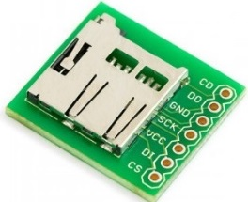

Figure 19.

MicroSD Card slot mounted on a breakout board manufactured by Sparkfun. Shown in the figure are the pins required to communicate via SPI to write and read data on a MicroSD card.

##### Microprocessor

The microprocessor it the main component used in the collar device. The selected microprocessor, PIC24F16KA101 (Figure 20) is a 16-bit microprocessor, operates at 3.3V and is an ultra-low powered module. The microprocessor has the required two serial ports, SPI communication capabilities, 9 10-bit ADC channels, and requires only 8µA current.

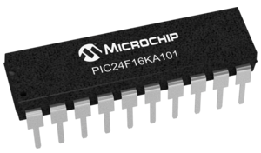

Figure 20.

PIC24F16KA101 as manufactured by Microchip.

The microprocessor communicates with the Wi-Fi module using the UART1 TX and RX pins. The U1TX pin of the microprocessor is connected to the U1RX pin of the Wi-Fi module and the RX pin to the TX pin of the Wi-Fi module, as shown in Figure 21.

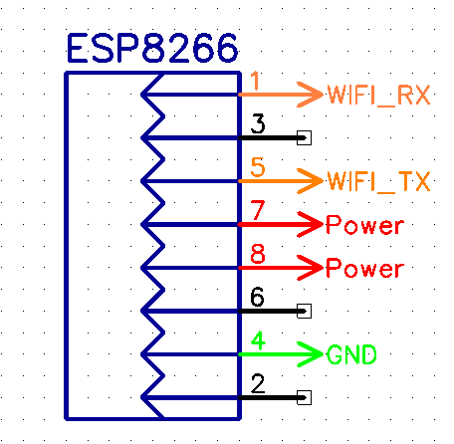

Figure 21.

Connections required for serial communication between the ESP8266 Wi-Fi Serial Transceiver and the PIC24F16KA101 microprocessor.

For communication to the XBee module, the microprocessor uses the UART2 TX and RX pins. The U2TX pin of the microprocessor is connected to the U2RX pin of the XBee module and the RX pin to the TX pin of the XBee module, also shown in Figure 22.

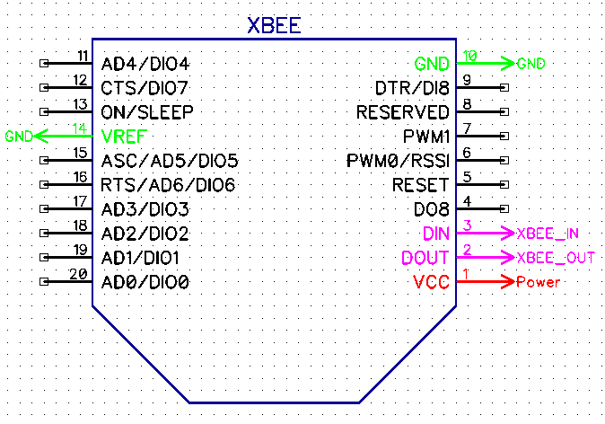

Figure 22.

Connections required for serial communication between the XBee Series 2 2mW module and the PIC24F16KA101 microprocessor.

The accelerometer is connected to the microprocessor using three analogue pins, one for each axis on the accelerometer. The x-axis is connected to analogue pin A1, the y-axis is connected to analogue pin A0 and the z-axis is connected to analogue pin A4, as shown in Figure 23. The configuration was chosen to simplify the circuitry for the PCB design, discussed in 3.2.1. (g).

---Fix Image

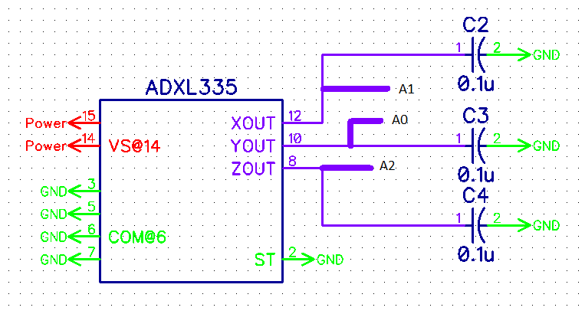

Figure 23.

Connections required to measure acceleration in 3-axis between the ADXL335 module and PIC24F16KA101 microprocessor.

The MicroSD card slot is connected to the microprocessor using the SPI communication pins, as shown in Figure 24 and Table 9.

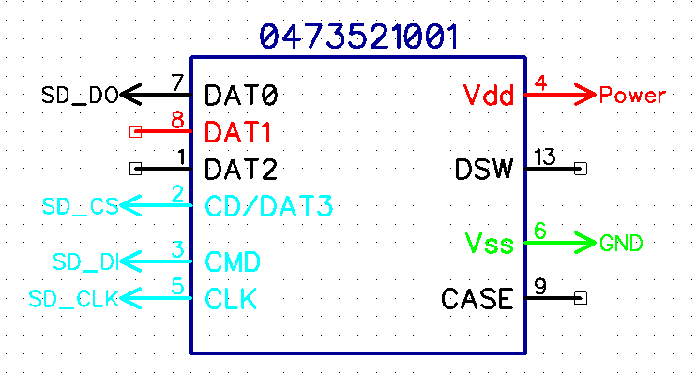

Figure 24.

Connections required for SPI communication between MicroSD Card and Microprocessor.

|  |  |
| --- | --- |
| Pin on MicroSD card slot | Pin on Microprocessor |
| DO (Data Out) | SDI (Pin 17) |
| DI (Data In) | SDO (Pin 16) |
| CS (Chip Select) | RB 9 (Pin 13) |
| CLK (Clock) | SCK1 (Pin 15) |

Table 9.

Pin configurations between MicroSD card slot and PIC24F16KA101 microprocessor.

Figure 25Figure 25. shows the flow of the software running on the microprocessor. Once the power is given to the microprocessor, the power on cycle (MP1) is initiated on the microprocessor. Thereafter the microprocessor clears the data buffer (sets each character to ‘\0’) to ensure the data registers are empty before data is received from the Wi-Fi module. The data buffer is an array of characters with a predefined size of 350 characters.

Once the data buffer is cleared, the ADC is configured to measure acceleration. The ADC is configured by setting the registers to the values shown in Table 10.

Next, the serial communications are configured, see Table 11. Both serial lines are configured with the same settings, except the baud rates differ. The Wi-Fi module is configured with a 9600-baud rate, and the XBee module with a 19200-baud rate. This is to minimalize cross talk between the modules.

|  |  |  |
| --- | --- | --- |
| Register | Value | Description |
| AD1PCFG | 0xFF7C | Set AN0, AN1 and AN4 as analogue pins. |
| AD1CON1 | 0x00E0 | Set internal counter to trigger conversion. |
| AD1CON2 | 0x003C | Clear ADC interrupt after 16 samples. |
| AD1CON3 | 0x0F00 | Set sample time. |

Table 10.

Configuration of registers for ADC on PIC24F16KA101 microprocessor.

|  |  |  |  |  |
| --- | --- | --- | --- | --- |
| Wi-Fi Module | | XBee Module | |  |
| **Register** | **Value** | **Register** | **Value** | **Description** |
| TRISB2 | 1 | TRISB | 1 | Set pin as digital input, and RX line for serial. |
| TRISB7 | 0 | TRISB | 0 | Set pin as digital output, and TX line for serial. |
| U1MODE | 0 | U2MODE | 0 | Clears register to default values. |
| U1STA | 0 | U2STA | 0 | Clears register to default values. |
| U1BRG | 25 | U1BRG | 12 | Sets baud rate for serial communication. |
| U1RXIE | 1 | U2RXIE | 1 | Enable RX interrupt. |
| UARTEN | 1 | UARTEN | 1 | Enable UART. |

Table 11.

Configuration of registers for serial communication between PIC24F16KA101 microprocessor and ESP8266 Wi-Fi Serial Transceiver module and XBee Series 2 2mW module respectively.

---Baud Rate Calculations

After the configuration is completed, the microprocessor delays for 5 seconds. This delay is to ensure the XBee module has sufficient time to register itself on the network before communication can occur. Thereafter the microprocessor goes into an infinite loop. In this loop, the microprocessor polls for proximity, determines sudden changes in movement and transmits data to the XBee module to be sent across the network.

The microprocessor polls for proximity by issuing the AT+CWLAP command to the Wi-Fi module. The Wi-Fi module’s response is captured by an interrupt on the microprocessor. The interrupt is called with every character received from the Wi-Fi module, and the character is stored in the data buffer. Once the data buffer is full (350 characters), the microprocessors disables the Wi-Fi module interrupt. This ensures that data can be transmitted to the XBee module without interruptions.

Before the data buffer is transmitted to the XBee module, sudden movement detection is initiated. Sudden movement is detected by sampling each axis, on its respective ADC channel. Each axis is sampled five times consecutively, and the measurement is stored in an array. Next each axis is sampled five times consecutively again, but the measurement is passed through equation (3). The equation subtracts the low-pass filter value of the current measurement from the initial simplified high-pass measurement. The results are stored in an array. The absolute sum of the result array is taken, and normalised by the number of results taken. The value returned is compared to a threshold value. The threshold value is a decimal value, pre-determined through trial and error, which symbolise the value required to show a sudden change in movement. If the result is lower than the threshold, no sudden change in movement occurred, and vice-versa.

$Change=Initial-(\left(Initial ×Filter\right)-(Sample ×(1-Filter)))$ (3)

If a sudden change is detected, the axis is flagged. The last three characters of the data buffered are equal to the X, Y and Z-axis flags respectively. When the axis is flagged, the character is set to ‘Y’; else, it is set to ‘N’.

Once the sudden changes are determined, the microprocessor transmits the data buffer to the XBee module to be transmitted to the web-node as discussed in 3.2.1. (c). Afterwards the data buffer is cleared once again, the Wi-Fi module enabled and the process is repeated until the collar device loses power.

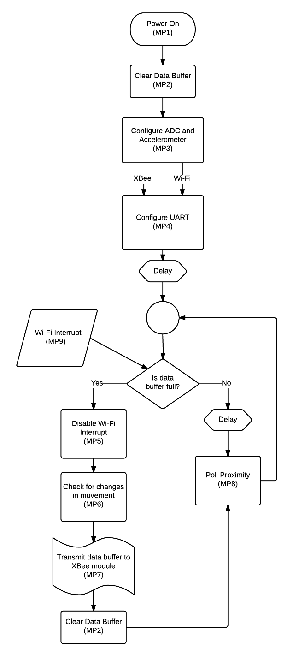

Figure 25.

Flow chart of software running on the PIC24F16KA101 microprocessor. The flow chart shows the configuration of registers in processes from the power on cycle of the microprocessor to the infinite loop of data polling.

##### Circuit Diagram

Figure 26 shows the final circuit diagram for the collar device as designed using DipTrace software. The software allowed for easy convertion to create the PCB design, shown in Figure 27.

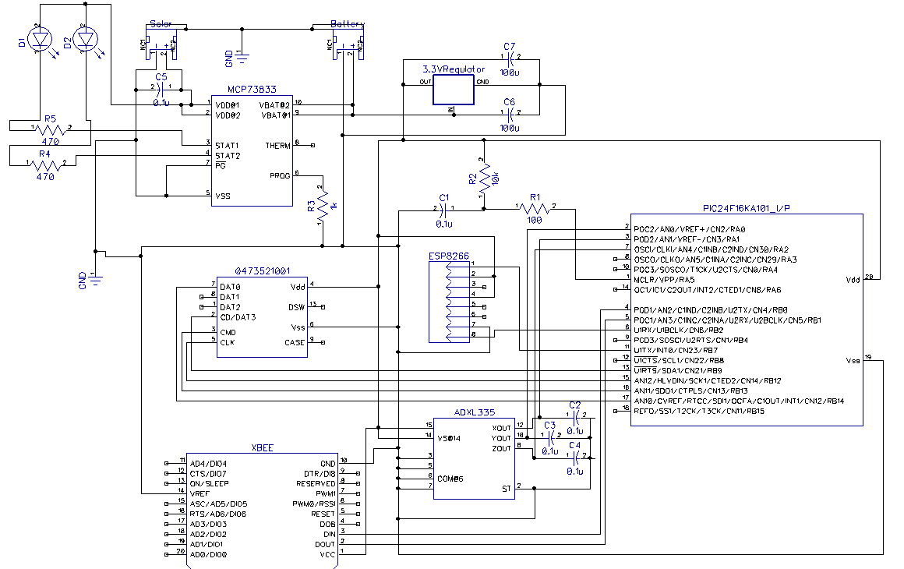

Figure 26.

Final Circuit Diagram for Collar Devices.

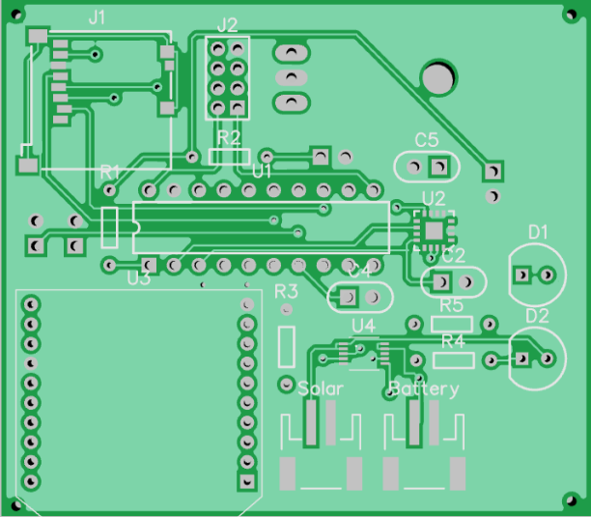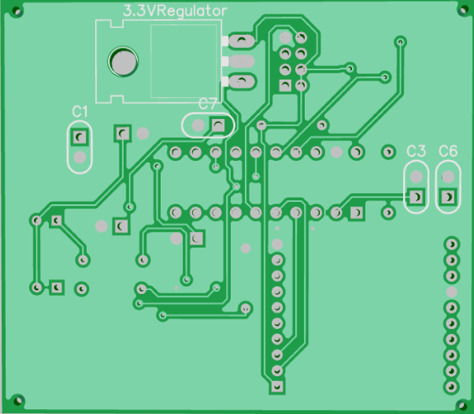

Figure 27.

Final PCB Design for collar devices. The left side image shows the top side of the PCB and the right side image shows the bottom of the PCB design.

Figure 28 shows the final PCB design with components in a 3D rendered model made using DipTrace.

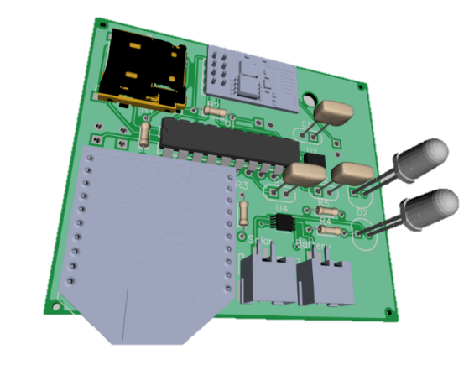

Figure 28.

3D Rendering of PCB design including components.

#### Enclosure Design

The enclosure is designed to house all the electrical components of the collar device, and is fixed to a collar that can safely be mounted on an animal. An isometric representation of the enclosure including the lid that is secured by 3mm screws is shown in Figure 29.

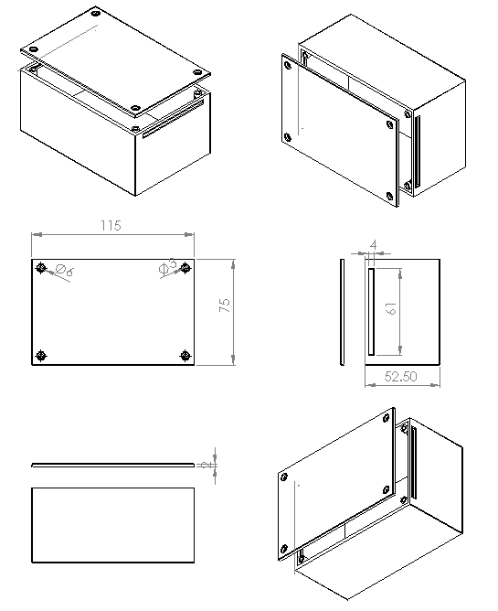

Figure 29.

Isometric sketch of enclosure design made using SolidWorks. All dimensions are given in millimetre.

The enclosure was to be 3D printed, but it was decided to buy enclosures with dimensions close to the design, due to time constraints and low quality of 3D printers available. A 3D representation of the design is shown in Figure 30.

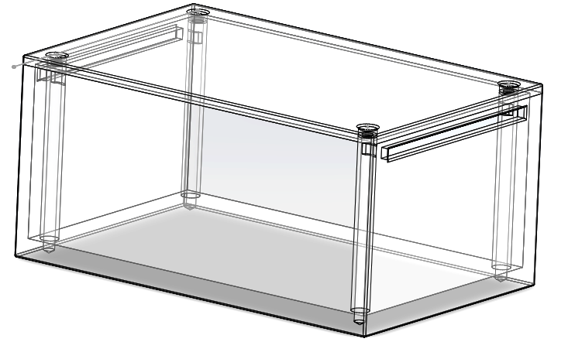

Figure 30.

3D Representation of enclosure design from 3D printing using SolidWorks.

The enclosures used, containing all the electrical components is shown in Figure 31. Since these enclosures do not have an opening to thread a collar through, collars are simply placed within the enclosure, and secured with screws as shown in Figure 32.

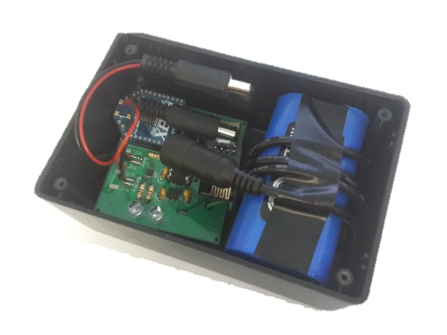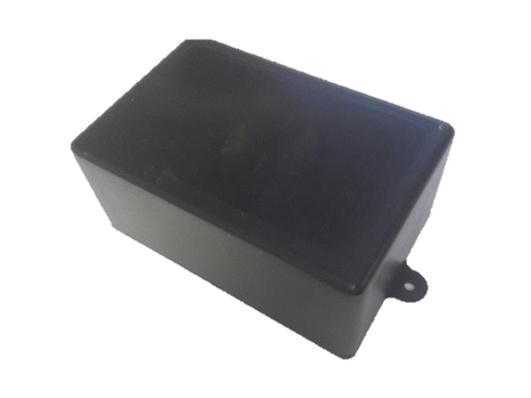

Figure 31.

Enclosures used, including electrical components for collar device.

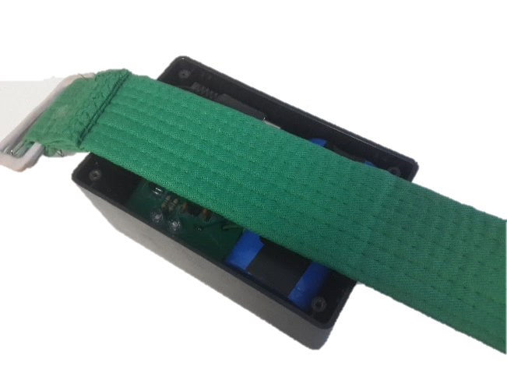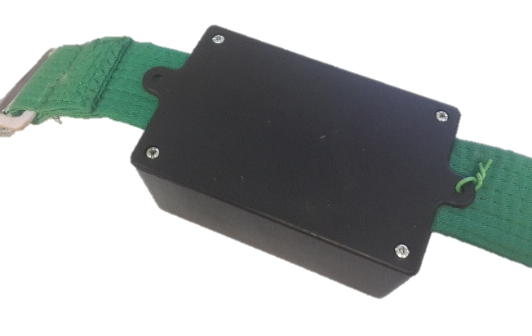

Figure 32.

Connecting an enclosure with components to a collar. The left-hand image shows how the collar is placed within the enclosure. The right-hand image shows how the enclosure is secured to the collar and closed.

The collar device is mounted to an animal by placing the collar around the animal’s neck or back, and threading the collar through the available buckle loops (Figure 33). An example is shown in Figure 34, where the collar is mounted on the back of a sheep (Dorper ewe) for testing purposes.

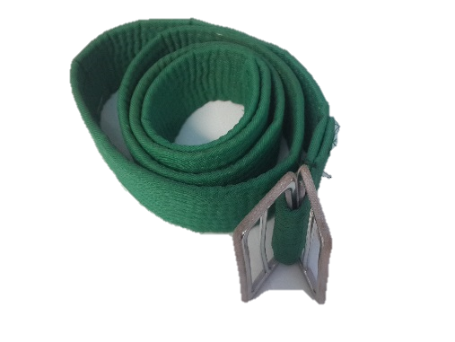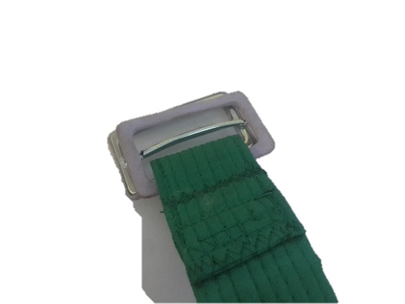

Figure 33.

Collar used, displaying the buckle loops to tighten the collar when mounting on an animal.

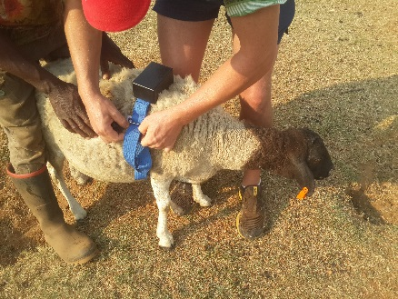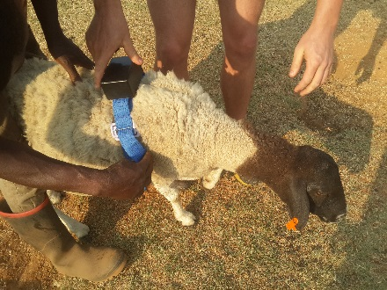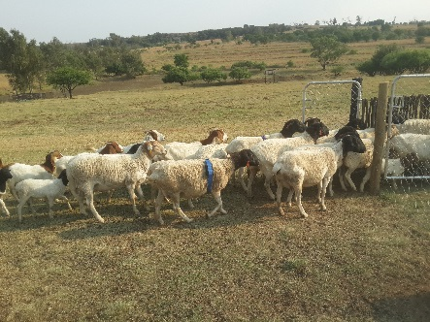

Figure 34.

Mounting a collar device on the back of a Dorper ewe.

#### Communication Protocol and Data Pre-Processing

The microprocessor transmits the full data buffer to the XBee module using serial communication as discussed in 3.2.1. (f). The XBee module packages the data into data packets and transmits the packets via the shortest route through the network to the web-node.

The web-node (see 3.2.1. (c)) is connected to a computer using a Serial-to-USB connection. The computer can be any computing device with an open USB connection port, and has a working installation of Python. The computer runs a Python script called Coordinator.py.

The script creates a communication line between the computer and XBee module. Packets are received by the XBee module from different collar devices at random intervals. The script uses the data structure, as described in 3.2.4. (b), to rebuild the data received from the packets, per source address. The script keeps track of all the collar devices within proximity of the collar device stated in the source address of the packet.

The script determines if the signal strength received in the data packet is within the proximity range. For collar devices to be within 2m of each other, the signal strength should be greater than -50dB (as calculated in Table 12). The packet contains a list of collar devices unique identifiers. The script determines the time collar devices are within proximity, and if sudden movement was detected on a collar device.

Once collar devices go out of proximity, the script transmits the data to the remote server via an Internet connection and a HTTP post. The script transmits the source address (collar devices unique identifier), the unique identifier of the device in proximity, the time the collar devices came in proximity and the time they left proximity. For sudden change in movement detection, the script transmits the source address and the axis of movement to the remote server using an Internet connection and a HTTP post.



Table 12.

Signal measurements between two collar devices for selected distances.

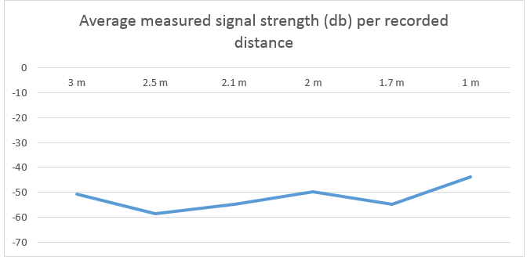

Figure 35.

Average signal strength for each recorded distance between two collar devices.

In both cases, the server responds with an integer value, as shown in Table 13, signify whether the remote server received the data, and if the data was with errors or not.

|  |  |
| --- | --- |
| Response Code | Definition |
| -1 | Unidentified error occurred. |
| 1 | Successfully logged. |
| 2 | Incorrect unique identifier for source device. |
| 3 | Incorrect unique identifier for device in proximity |
| 4 | Not all parameter where supplied. |
| 5 | Data could not be inserted into database. |
| 6 | Source device is not connected to an animal. |
| 7 | Device in proximity is not connected to an animal. |
| 8 | Invalid unique device identifier. |
| 9 | Device not connected to an animal. |

Table 13.

Remote server responses for data logging.

#### Software Design and Implementation

##### Database description

Acting as the central data point for the project, a database designed and developed in Microsoft SQL Server is running on the remote server at all times. The database consists of 30 data tables, and is described in Table 14.

|  |  |  |
| --- | --- | --- |
| Table Name | Type | Purpose |
| aspnet_Applications | ASPNET | Used internally for ASP.NET Framework |
| aspnet_Membership | ASPNET | Stores user passwords |
| aspnet_Paths | ASPNET | Used internally for ASP.NET Framework |
| aspnet_PersonalizationAllUsers | ASPNET | Used internally for ASP.NET Framework |
| aspnet_PersonalizationPerUser | ASPNET | Used internally for ASP.NET Framework |
| aspnet_Profile | ASPNET | Stores user details |
| aspnet_Roles | ASPNET | Stores permissions for GUI |
| aspnet_SchemaVersions | ASPNET | Used internally for ASP.NET Framework |
| aspnet_Users | ASPNET | Stores user details |
| aspnet_UsersInRoles | ASPNET | Links users with permissions |
| aspnet_WebEvent_Events | ASPNET | Used internally for ASP.NET Framework |
| a_DeviceLinks | Associative | Links a device to an animal |
| l_AnimalTypes | Lookup | Stores animal species labels |
| l_Axis | Lookup | Stores movement axis labels |
| l_BirthTypes | Lookup | Stores birth type labels |
| l_NotificationTypes | Lookup | Stores notifications type labels |
| l_Sexes | Lookup | Stores animal sex labels |
| t_Animals | Data Table | Stores details about animal |
| t_BirthHistory | Data Table | Stores history of births given by animals |
| t_Companies | Data Table | Stores details of companies |
| t_Devices | Data Table | Stores details of collar devices owned |
| t_Movement | Data Table | Stores a log of movements by animals |
| t_Notifications | Data Table | Stores a log of notifications sent |
| t_Proximity | Data Table | Stores proximity data between animals |
| t_PublicRegistrar | Data Table | Links male animals to public registry |
| t_Relationships | Data Table | Stores parent-child relationships of animals |
| t_Spermbank | Data Table | Stores details about insemination tubes |
| t_TubeHistory | Data Table | Stores history of tubes used by animals |
| t_UserNotifications | Data Table | Stores notification settings per user |
| t_Users | Data Table | Links users to auditable actions |

Table 14.

Tables used in database design with summary of the use of the table.

A detailed diagram of the database is shown in Figure 36. The figure shows the primary key (table columns marked with a key symbol ), and foreign key relationships, as well as the columns for each table. Foreign key constraints have been implemented in the database to ensure data integrity. Rows of data are never removed from the database; only “Removed” columns in the tables are set to “True”. This keeps the data auditable. An audit trail is also established in the database by tables containing the “ModifiedBy” and “ModifiedDate” columns. This is to keep track of when a record is inserted or changed and by which specific user.



Figure 36.

Database diagram.

To insert, edit and remove data from the database, the database makes use of Stored Procedures, as described in 3.2.4. (e). The database makes use of Microsoft SQL Server’s built in indexing. Over time, the indexing automatically detects columns that are mainly used when data queries are executed and indexes the relevant column to speed up execution time.

##### Internal software data structure

The data pre-processing python script uses three internal data structures to keep track of each collar device in the network and its respective collar devices within proximity, as listed below:

1. Nodes – A representation of the entire network.
2. DeviceNodes – A representation of a collar device within the network.
3. AnimalNodes – A representation of a collar device within proximity of a DeviceNode.

A single node is created to represent the network, and consists of an array of DeviceNodes. DeviceNodes each have their own unique address, or unique identifier. Furthermore, DeviceNodes have a data buffer and an array of connected AnimalNodes. Lastly, AnimalNodes consist of an address, or unique identifier, the time when the AnimalNode was initially connected to its parent DeviceNode, a field to store the signal strength and a time when the AnimalNode lost connection from its parent DeviceNode. The three data structures are represented visually in Figure 37.

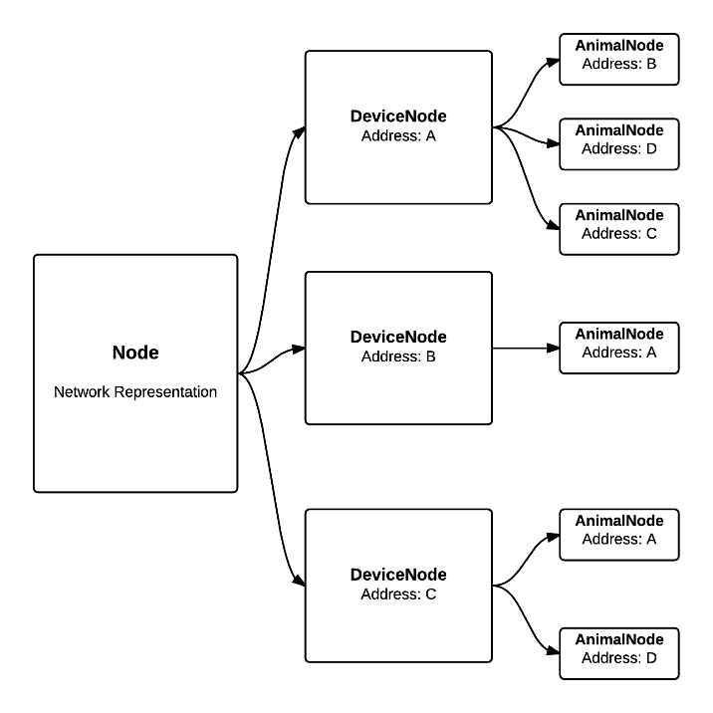

Figure 37.

Example of internal data structure used by data pre-processor.

##### Architectural and component-level design

The larger part of the project’s software is programmed using the MVC architecture. Figure 38 shows how this architecture is used.

MVC, or Model View Control, is used as the base architecture and framework running on the remote server. The framework is implemented using ASP.NET, to create a web-based platform, allowing both users and web-nodes to interact with data stored on the database.

Referring to the Model (A1.1) is a collection of Data Models (A1.4) and Model Repositories (A1.5). Models (see 3.2.4. (f)) are used to interact with the Database (A1.7) through a series of Stored Procedures (A1.6), to store and retrieve data. Views (A1.3) refers to webpages, accessible to the user. The views build the user interface (see 3.2.4. (g)) using data passed by the Data Models (A1.4). Controllers (A1.2) are used to control the interface, and redirect users to the correct Views (A1.3) or webpages, based on the User Actions (A2.1) inputted. The Controllers (A1.2) are responsible for populating the data in the Data Models (A1.4) by accessing functions in the Model Repositories (A1.5), based on a set of control rules given the required User Action (A2.1), further explained in 3.2.4. (h).

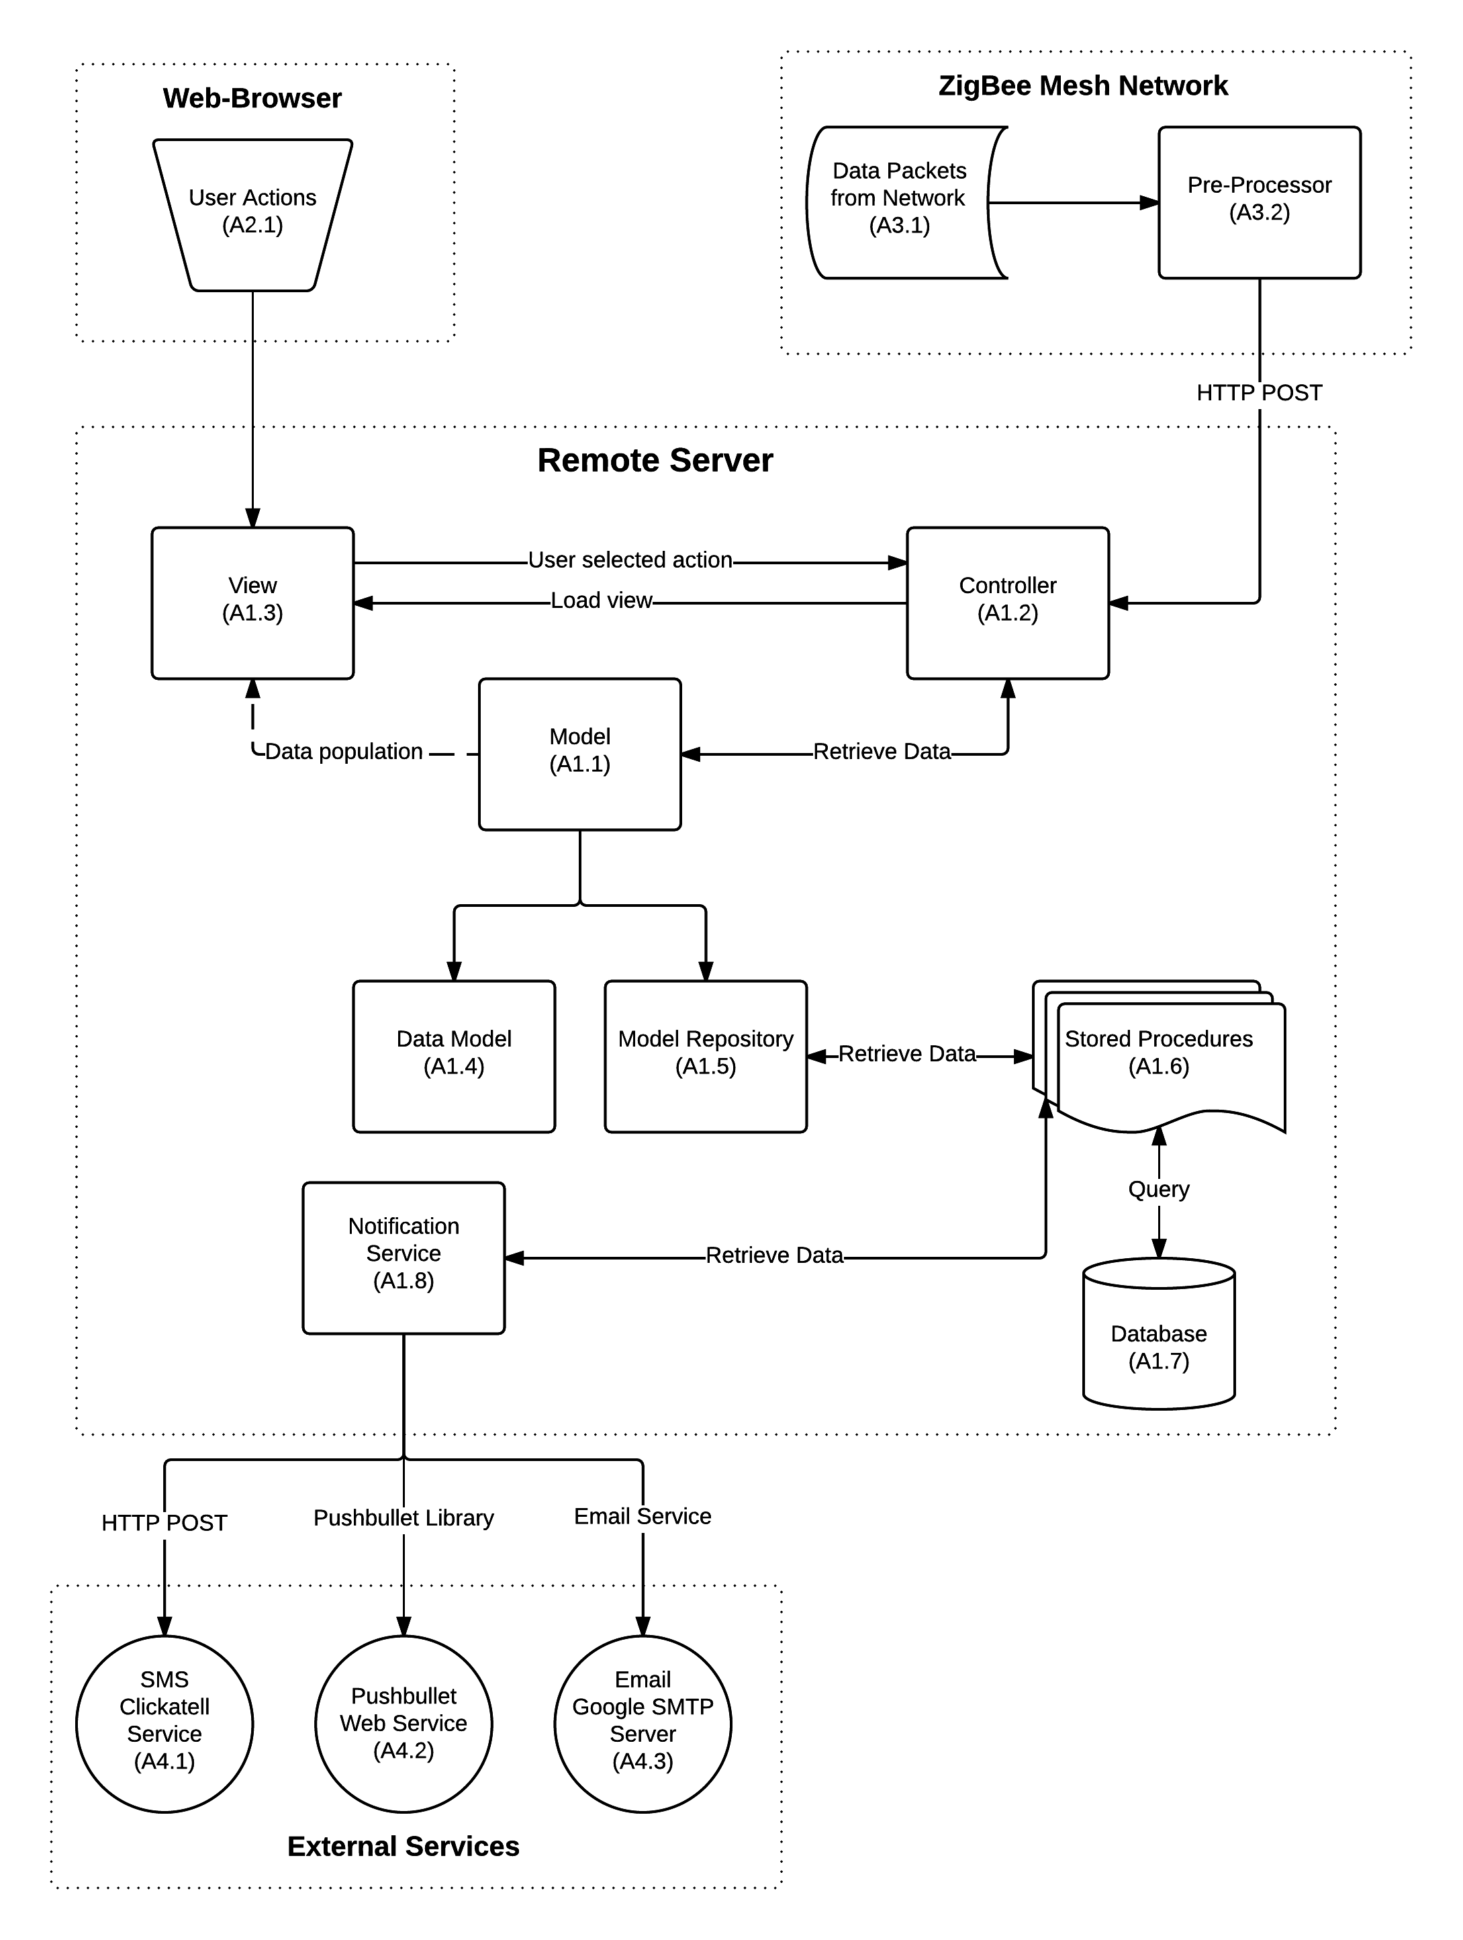

Figure 38.

Project architecture diagram.

The Pre-Processor (A3.2) receives Data Packets (3.1) via the network, and transmits the processed data (see 3.2.4. (d)) by using HTTP POST requests. The requests can be seen as User Actions (A2.1), and the Controller (A1.2) controls the requests based on the set of control rules for the given action, as explained in 3.2.4. (h).

The Notification Service (A1.8) is a service that runs at given intervals on the remote sever to determine estrous behaviour, and notify the users accordingly, as discussed in 3.2.4. (k). The Notification Service (A1.8) uses direct access to the Stored Procedures (A1.6) to retrieve data from the Database (A1.7) to determine estrous behaviour. Once the processing is done, notifications are sent using three methods. All three methods used communicate to external services before sending notifications to users.

Clickatell provides functionality to send SMS notifications (A4.1) to users. HTTP GET requests are used to communicate with the API provided by Clickatell’s service. For push notifications (A4.2) on the mobile application PushBullet, the PushBullet API is used. The API uses internal communication functions to communicate data to the PushBullet service, from where notifications are sent. Lastly, E-Mail notifications (A4.3) are sent using Google’s open-source SMTP mail server, and using mail service commands within the Notification Service (A1.8).

##### Description for Data Pre-Processing

The data pre-processor (A3.2) is a python script that can run on any computing device with an available USB port and internet connectivity. The script uses the data structures described in 3.2.4. (b).

The script has only one global variables, the Node data structure, referred to as the network. The script starts by establishing a USB-serial connection with the connected XBee Pro Series 2 63mW module, configured as a Coordinator device. Once the communication is established, the script is ready to receive data packets from the XBee module.

Once a packet arrives, the script deconstructs the packet to determine the source address, or unique identifier of the collar device that transmitted the packet. It is determined if the collar device is already added to the network. If the collar device is not present in the network, a new DeviceNode is created and added, otherwise the collar devices’ index within the network is found and its corresponding DeviceNode is retrieved. The data received in the packet is then added to the DeviceNode’s data buffer.

The data buffer is then checked to see if it has successfully rebuilt the data received from the multiple packets sent by the collar device. A “~” at the end of the buffer signifies that the data buffer is full, and has been rebuilt successfully. The accelerometer flags within the data buffer is checked, and the corresponding data members are flagged with the DeviceNode.

Once the data buffer is full, a thread is started and the DeviceNode is processed. The processing starts by processing the data buffer. To process the data buffer, the script uses string manipulation to determine unique identifiers of collar device in proximity. The unique identifiers are stripped from the data buffer, and for each unique identifier found, a new AnimalNode is created and added to the connections array of the DeviceNode. After the data buffer has been processed, the connection array is returned and the lost connections are determined. This is done by comparison between the returned connection array, referred to as the new connections, and the connection array of the DeviceNode. For every connection not listed in the new connections array, the connection, AnimalNode is added to a lost connection array, and returned. This array contains all the collar devices no longer in proximity of the parent collar device.

Every lost connection is the pushed to the remote server. This is accomplished by using a HTTP POST request. The parameters, shown in Table 15, are added to a HTTP POST packet, and transmitted to the remote server via the Internet connection. The remote server responds with the one of the response codes as stated in Table 13.

|  |  |
| --- | --- |
| Parameter | Description |
| DeviceReceivedAddress | Unique identifier of collar device |
| DeviceConnectedAddress | Unique identifier of collar device within proximity |
| ConncetionStart | Time collar devices came within the proximity range |
| ConnectionEnd | Time collar device left the proximity range |

Table 15.

Parameters required to transmit proximity data to remote server using HTTP POST request.

After proximity data is transmitted to the remote server, the DeviceNode’s movement flags are checked. If it a movement axis has been flagged to shown sudden change in movement for the specified axis, the data is transmitted to the remote server. As with the proximity data, movement data is transmitted to the remote server using a HTTP POST request. The parameters, shown in Table 16, are added to a HTTP POST packet, and transmitted to the remote server via the Internet connection. The remote server responds with the one of the response codes as stated in Table 13.

|  |  |
| --- | --- |
| Parameter | Description |
| DeviceAddress | Unique identifier of collar device showing movement |
| Axis | Axis of movement |

Table 16.

Parameters required to transmit movement data to remote server using HTTP POST request.

##### Description for Stored Procedures

Stored procedures (A1.6) are subroutines available to applications accessing the project’s database. The stored procedures are part of the database’s dictionary. The database has 116 defined stored procedures. This section will explain the base design of the stored procedures.

Stored procedures are developed using Transact SQL, or T-SQL statements. The procedures are pre-defined SQL statements that allow the application accessing the procedure to insert, update, remove and select data from the database. Stored procedures are execute within a SQL transaction. This allows the database to verify the data before it is inserted, and if an error occurs, the database is able to roll back the transaction without effecting any data in the database. Stored procedures are preferred above directly interacting with the database using SQL statements, is to prevent SQL injections. Stored procedures remove the requirement of updating and recompiling the software running on the remote server, when changes within the database occur.

For each table in the database, five stored procedures are defined (see Table 17). The T-SQL statements used in the respective five stored procedures are the same for each table, only changing the table, respective columns used and parameters passed to the procedure. The stored procedures and use the following naming convention: usp_<Table Name><Stored Procedure>, where <Table Name> is replaced with the name of the table to be used (see Table 14), and <Stored Procedure> with the stored procedure to be used.

|  |  |  |
| --- | --- | --- |
| Stored Procedure | Parameters | Functionality |
| Insert | Data columns of table | Inserts data into table |
| Update | Data columns of table, and primary key of row to be updated | Updates a row in table |
| Delete | Primary key of row to be removed | Deletes a row in table |
| Select | Primary key of row to be selected | Selects a single row from table |
| Select_All | CompanyID, or empty parameters | Selects all rows in a table with the same CompanyID supplied |

Table 17.

Basic stored procedures of each table in the database.

In addition to the basic stored procedures used by each table, several stored procedures were developed with specific functionality aimed at determining estrous behaviour and determining managerial actions best suited for a female animal showing estrous behaviour. These stored procedures are summarised in Table 18 and primarily used by the notification service, as discussed in 3.2.4. (k), and use the following naming convention: service_<Stored Procedure> where <Stored Procedure> is replaced with the stored procedure to be used, as in Table 18.

|  |  |  |
| --- | --- | --- |
| Stored Procedure | Parameters | Functionality |
| GetAIHistoryForAnimal | Animal ID | Returns a history of artificial insemination tubes used by the select animal. |
| GetBirthHistoryForAnimal | Animal ID | Returns a history of births given by the selected animal. |
| GetEstrousFromInteractions | Test Date and Sensitivity Factor | Returns a list of Animal IDs where the animal has increased interactions greater than the historical amount of interactions times the sensitivity factor for a given test date. |
| GetEstrousFromInteractionTime | Test Date and Sensitivity Factor | Returns a list of Animal IDs where the animal’s average interaction time is greater than the historical average of interactions time, times the sensitivity factor for a given test date. |
| GetGeneticBirthingSuccessRatio | Animal ID | Returns a percentage equal to the birthing success of the females of the selected animal’s family tree. |
| GetHistoricMaleSocialGroup | Animal ID | Returns a list of male Animal IDs where the list of males are selected based on the most amount of time and interactions spent with the selected animal. |
| GetInteractions | Animal ID | Returns the last 10 interactions of selected animal, and the length of the interactions. |
| GetInteractionsAll | None | Returns the top 5 Animal IDs for each animal, based on the most time and interactions between the selected animals. |
| GetInteractionsAllGiveTime | Start and End Date | Returns the top 5 Animal IDs for each animal, based on the length of interactions between the selected animalsbetween the specified start and end dates. |
| GetInteractionsGivenTime | Start and End Date | Returns the top 5 Animal IDs for each animal, based on the number of interactions between the selected animalsbetween the specified start and end dates. |

Table 18.

Summary of stored procedures used by notification service.

##### Description for Models

Models (A1.1) are the main data components use within the web-based software running on the remote server. There are three types of models used within the software: Data Models, View Models and Model Repositories.

For each table in the database a Data Model is created. A Data Model is a C# class, with all public members, each set to the equivalent data type and name of the corresponding column within the table. A Data Model represents a row in the corresponding table. Table 19 shows a summary of the Data Models and its corresponding functionality.

|  |  |
| --- | --- |
| Data Model | Functionality |
| Animal | Data structure for animal record. |
| AnimalType | Data structure for animal type record relating to the animals species. |
| BirthHistory | Data structure for birth history record. |
| BirthType | Data structure for birth type record relating to insemination method used. |
| Company | Data structure for company able to use software. |
| Device | Data structure for device record. |
| InseminationHistory | Data structure for insemination history record of a specified animal. |
| InseminationTube | Data structure for insemination tube record. |
| MovementLog | Data structure for movement record. |
| ProximityLog | Data structure for proximity record. |
| PublicRegistrar | Data structure for public registrar relating to animals publicly registered. |
| User | Data structure for user record relating to details required to log in. |
| UserNotification | Data structure for user notification setting record. |

Table 19.

Data Models used within the software architecture.

View Models are models specifically designed and developed for displaying large amounts of data. A View Model is a C# class with public members, where some datatypes are set to other View Models or Data Models. View Models are specifically used when the only has to be displayed, without any further actions required.

---Table of view models

Model Repositories are models purposed to contain only functions used to populate Data and View Models with data from the database, and to stored or update data based on the Data Models in the database. Repositories are grouped based on their relevant part within the software architecture and may include data population functions for one or more Data and View Models. Repositories make use of SQL Server connections, from which the repository can access the Stored Procedures (discussed in 3.2.4. (e)). Parameters are passed from the repositories to the Stored Procedure and the result returned from the stored procedure is used to populate the Data Models. When one or more records are returned from the Stored Procedures, a list of Data Models are used to populate the data for use within the software.

---Table of repositories

---Main functions in repositories, Insert, Update and Remove

##### Description for Views

---Explain use of views

##### Description for Controllers

---Explain use of Controllers

##### Description for Estrous Behaviour Detection

---Explain Code in Console Service

---Flow Chart

##### Description for Estrous Management

---Explain Manage Service

---Decision Tree

##### Description for Notification Service

---Explain code to notify users

##### Software interface description

---HTTP POST

##### User interface design

---ASP.NET

---Telerik Grids

---Screen Shots

##### Description for System Simulation

---Explain why simulation was done

---Explain code behind simulation

### Design Summary

This section summarises the project tasks and how they were implemented (see Table 20).

|  |  |  |
| --- | --- | --- |
| Task | Implementation | Task Completion |
| Design and develop software and hardware to determine proximity between collar devices. | Hardware in the form of ESP8266 Wi-Fi modules were taken of the shelf and used to determine signal strength between devices. Software was developed in Python to determine proximity based on signal strength. | Completed |
| Design a ZigBee Mesh Network to transmit data from the collar devices to a remote server. | A ZigBee Mesh Network was configured using XCTU software and XBee Series 2 modules. Software was developed in Python to receive data at an Internet-enabled computer, to communicate to the remote server. | Completed |
| Investigate power requirements and the use of solar power to increase battery lifetime. | Calculations were done to determine the expected battery lifetime, based on the average power usage of components and the batteries available for the project. Solar power was investigated and incorporated as an option extra for use in the project. | Completed |
| Develop on-board storage capabilities for collar devices. | Provisions were made to allow the use of a MicroSD card, to be communicated to through SPI communication. The task was left incomplete due to time restrictions and lack of memory by microprocessor used. | Incomplete |
| Design and develop software to determine sudden changes in movement. | An accelerometer was taken of the shelf, and software was developed in MPLAB X. | Completed |
| Design of a PCB for the electronics required in the collar device. | The PCB design was completed, using the DipTrace package. This was done from first principles. | Completed |

Table 20.

Technical design tasks done for the project.

|  |  |  |
| --- | --- | --- |
| Design an enclosure to house collar device electronics. | A design was done using SolidWorks. | Completed |
| Design a collar to mount the collar device to animals. | A belt was used off the shelf that can be connected to the collar device and mounted to an animal. | Completed |
| Design and develop a web-based user interface. | A web-based user interface was developed using Visual Studio 2013 and the ASP.NET MVC framework. | Completed |
| Design a database to store data gather from collar devices. | A database was designed and developed form first principles using SQL Server Management Studio. | Completed |
| Develop algorithms to determine estrous behaviour in female animals based on proximity data gather by collar devices | Algorithm were developed using a combination of SQL Stored Procedures and C# code. | Completed |
| Develop a user notification system. | A user notification system was developed in C# capable of notifying user of animals showing estrous behaviour | Completed |
| Develop a decision tree and algorithm to help users make managerial decisions for female animals showing estrous behaviour. | A decision tree was designed to provide users with suggested managerial decisions. The decision tree was translated to an algorithm and developed in C#. This was done specifically for beef cattle. | Completed |

Table 20. (Continued)

Technical design tasks done for the project.

## Results

### Summary of results achieved

### Qualification tests

### Results and observations

## Discussion

### Interpretation of results

### Aspects to be improved

### Strong points

### Under which circumstances will the current system fail?

### Design ergonomics

### Health and safety aspects of the design

### Social and legal impact and benefits of the design

### Environmental impact and benefits of the design

## Conclusion

### Summary of the work

### Summary of the observations and findings

### Suggestions for future work

## References

|  |  |
| --- | --- |
| [1] | J. Roelofs, F. López-Gatius, R. Hunter, F. van Eerdenburg and C. Hanzen, “When is a cow in estrus? Clinical and practical aspects,” *Theriogenology,* vol. 74, no. 3, pp. 327-344, 2010. |
| [2] | R. Esslemont, R. Glencross, M. Bryant and G. Pope, “A quantitative study of pre-ovulatory behaviour in cattle (British Friesian heifers),” *Applied Animal Ethology,* vol. 6, no. 1, pp. 1-17, 1980. |
| [3] | J. Solano, A. Orihuela, C. Galina, F. Montiel and F. Galindo, “Relationships between social behaviour and mounting activity of Zebu cattle (Bos indicus),” *Applied Animal Behaviour Science,* vol. 94, no. 3-4, pp. 197-203, 2005. |
| [4] | G. Sveberg, A. Refsdal, H. Erhard, E. Kommisrud, M. Aldrin, I. Tvete, F. Buckley, A. Waldmann and E. Ropstad, “Sexually active groups in cattle—A novel estrus sign,” *Journal of Dairy Science,* vol. 96, no. 7, pp. 4375-4386, 2013. |
| [5] | J. Drewe, N. Weber, S. Carter, S. Bearhop, X. Harrison, S. Dall, R. McDonald and R. Delahay, “Performance of Proximity Loggers in Recording Intra- and Inter-Species Interactions: A Laboratory and Field-Based Validation Study,” *PLoS ONE,* vol. 7, no. 6, p. e39068, 2012. |
| [6] | R. Walrath, T. Van Deelen and K. VerCauteren, “Efficacy of proximity loggers for detection of contacts between maternal pairs of white-tailed deer,” *Wildlife Society Bulletin,* vol. 35, no. 4, pp. 452-460, 2011. |
| [7] | C. O’Neill, G. Bishop-Hurley, P. Williams, D. Reid and D. Swain, “Using UHF proximity loggers to quantify male–female interactions: A scoping study of estrous activity in cattle,” *Animal Reproduction Science,* vol. 151, no. 1-2, pp. 1-8, 2014. |
| [8] | B. Silper, I. Robles, A. Madureira, T. Burnett, M. Reis, A. de Passillé, J. Rushen and R. Cerri, “Automated and visual measurements of estrous behavior and their sources of variation in Holstein heifers. I: Walking activity and behavior frequency,” *Theriogenology,* vol. 84, no. 2, pp. 312-320, 2015. |
| [9] | A. Chanvallon, S. Coyral-Castel, J. Gatien, J. Lamy, D. Ribaud, C. Allain, P. Clément and P. Salvetti, “Comparison of three devices for the automated detection of estrus in dairy cows,” *Theriogenology,* vol. 82, no. 5, pp. 734-741, 2014. |
| [10] | S. Edwards, G. Bo, K. Chandra, P. Atkinson and M. McGowan, “'Comparison of the pregnancy rates and costs per calf born after fixed-time artificial insemination or artificial insemination after estrus detection in Bos indicus heifers,” *Theriogenology,* vol. 83, no. 1, pp. 114-120, 2015. |
| [11] | wikiHow, “How to Know when a Heifer or Cow Is Ready to Be Bred,” wikiHow, 2015. [Online]. Available: http://www.wikihow.com/Know-when-a-Heifer-or-Cow-Is-Ready-to-Be-Bred. [Accessed 28 September 2015]. |
| [12] | University of Nebraska–Lincoln, “Pregnant cows, timing of pregnancy, open cows, pregnancy rate,” UNL Beef, 2015. [Online]. Available: http://beef.unl.edu/pregnantcows. [Accessed 28 September 2015]. |
| [13] | S. Johnson, “Possibilities with today's reproductive technologies,” *Theriogenology,* vol. 64, no. 3, pp. 639-356, 2005. |
| [14] | M. Dransfield, R. Nebel, R. Pearson and L. Warnick, “Timing of Insemination for Dairy Cows Identified in Estrus by a Radiotelemetric Estrus Detection System,” *Journal of Dairy Science,* vol. 81, no. 7, pp. 1874-1882, 1998. |

# Part 4. Technical documentation

This main report is supplemented with technical documentation. This provides more detail on the software that was used in the experiments, including program listings, a user guide and circuit designs. This section appears on the CD or DVD that accompanies this report.

The CD/DVD is organised as follows: (give the directories as they appear on the CD).